Literacy:

1. Handwriting warm up: practice forming the letters c a d g o s

(remember to say the description for each letter as you write it).

1. Today is the day when you cut out your finger puppets for our Jack and the Beanstalk story.

* I want you to use your best cutting out skills and then make a puppet show of the story.
* If your grown up can video your show and upload it to Tapestry, I’d love to see it!
* Remember to use your story book language

Once upon a time, there was a …

Physical: Do a crab walk!

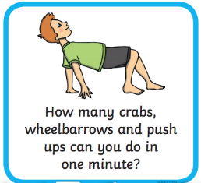

This week’s

Expressive Arts and Design

Make the Giant’s castle. You can use any materials that you have in your house. You can draw or use old boxes. You could use lego or even cut up pictures from magazines. You choose! Take a picture and put it on Tapestry.

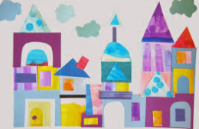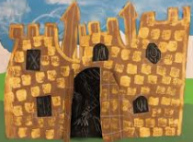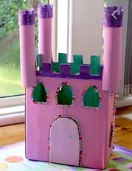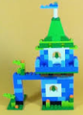

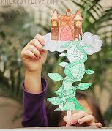

Song



<https://www.bbc.co.uk/teach/school-radio/nursery-rhymes-ten-fat-sausages/z6vh7nb>

Maths: **Finding half of numbers to 20**.

Find a group of objects you can count (pieces of dried pasta, pebbles, buttons, beads, toy cars, lego bricks).

Count out 12. Get 2 teddies and share the buttons equally between them so they have half each.

What is half of 12? Repeat with 14, 16, 18 and 20 objects. Did you discover a pattern?

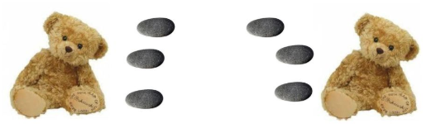

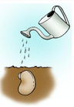

**Phonics – this video demonstrates how to say the pure sounds** <https://www.youtube.com/watch?v=qB6SvZscxgg>

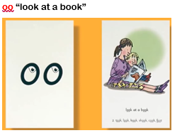

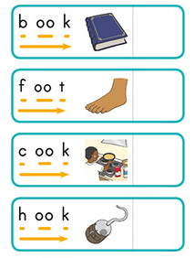Quickwrite these words. Then write a sentence about the book you like best.

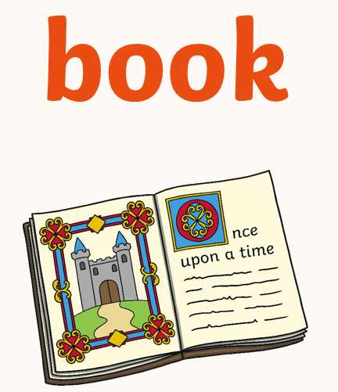

Phonics Play - Buried Treasure

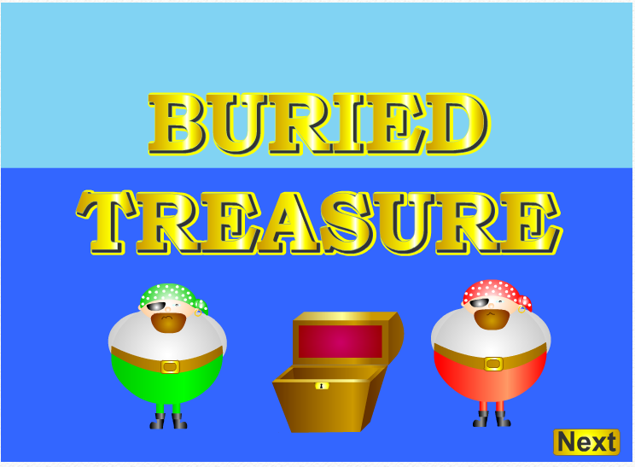

<https://www.phonicsplay.co.uk/Phase2Menu.htm>

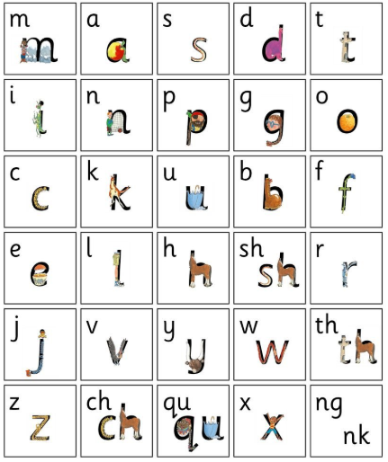

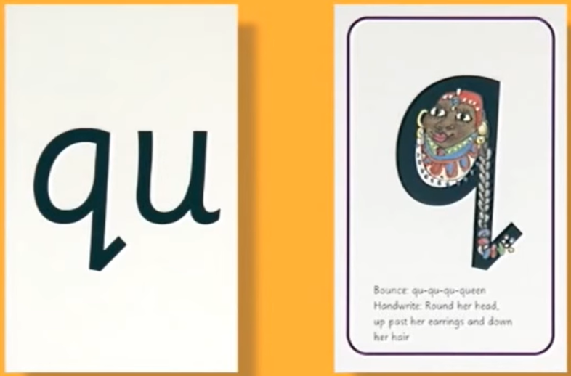



Play Buried Treasure with the q sound <https://www.phonicsplay.co.uk/BuriedTreasure2.html>

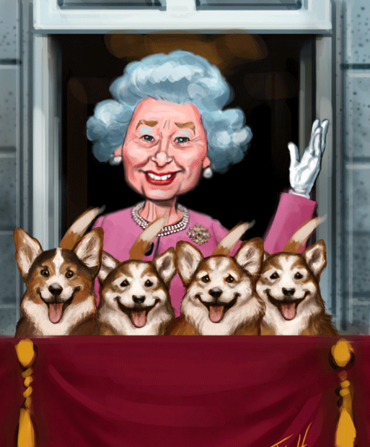

Then write a sentence about the queen and her dogs.

