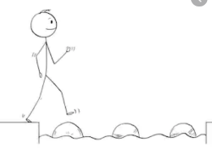
Year 4 Maths
Steppingstone activity
Lesson 4
LO: To subtract two 4-digit numbers
Success Criteria:
- Write out the calculation – check digits are in the correct columns!
- Subtract the bottom ones digit from the top ones digit.
- Subtract the bottom tens digit from the top tens digit.
- Subtract the bottom hundreds digit from the top hundreds digit.
- Subtract the bottom thousands digit from the top thousands digit.
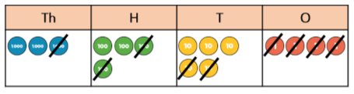
Model

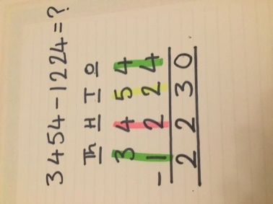
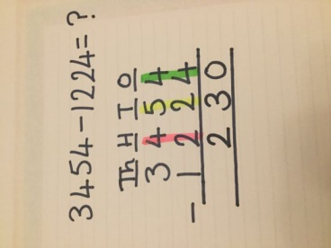
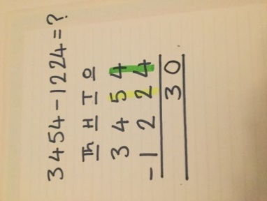
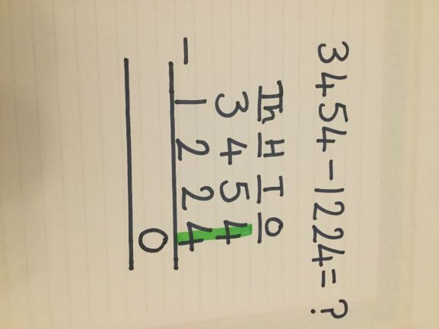
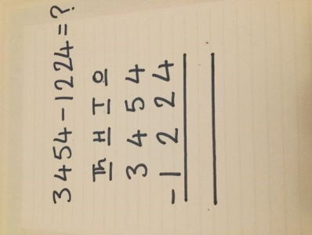
- 2. 3. 4. 5.

Now you try…

- 2. 3.
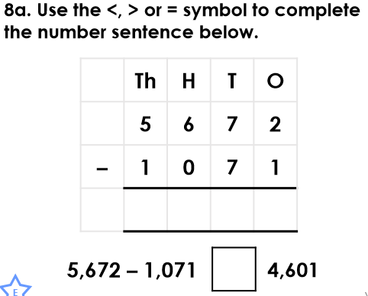
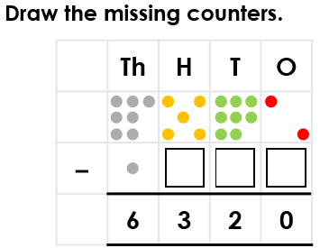
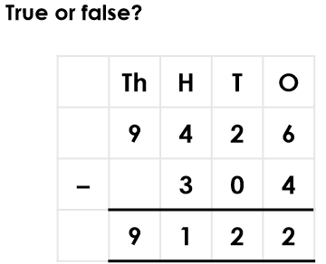

Year 4 Maths
Lesson 4
LO: To subtract two 4-digit numbers
Task:
You are going to practise subtracting with exchanges.
Success Criteria for 5643 - 4316
- Write out the calculation – check digits are in the correct columns!
- Can you subtract the bottom digit from the top digit? No. Exchange one ten for ten ones.
- Subtract the bottom one from the new 2-digit number above.
- Go to the tens column and subtract the bottom ten from the new top ten.
- Subtract the bottom hundreds digit from the top hundreds digit.
- Subtract the bottom thousands digit from the top thousands digit.
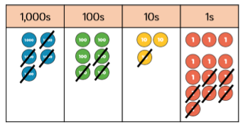
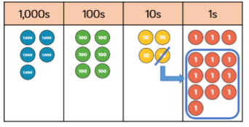
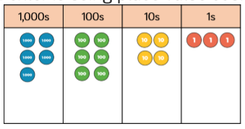
Model:

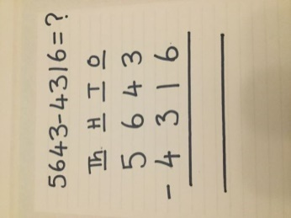
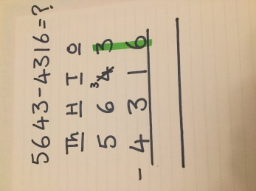
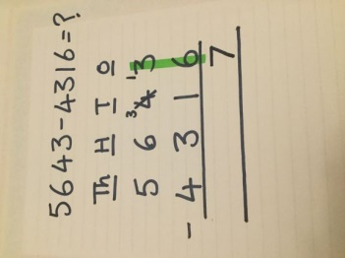
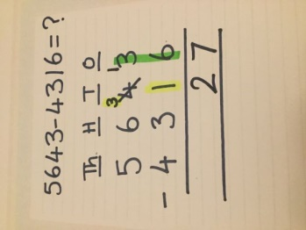
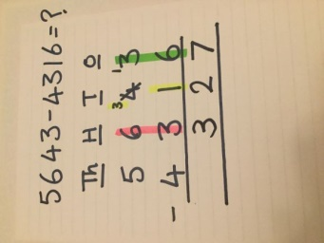
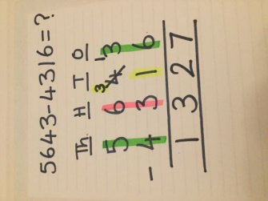
1. 2. 3. 4. 5. 6.

Make sure all your answers are in the correct columns!!!
Year 4 Maths
Main activity
Complete at least 2 columns, more if you can!
Task 1 | Task 2 | Task 3 | Task 4
Practice  Have a go at these subtractions (more than one exchange)  6741 – 3912 =  2805 – 1943 =  5237 - 5159 =  5063 – 3258 =  3764 – 2829 = | Practice  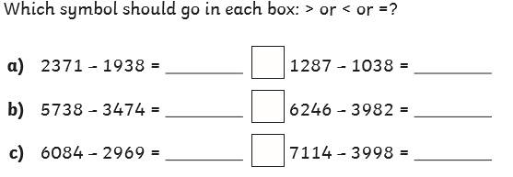 | Reasoning  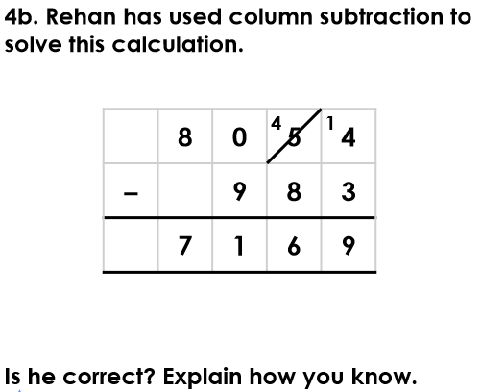  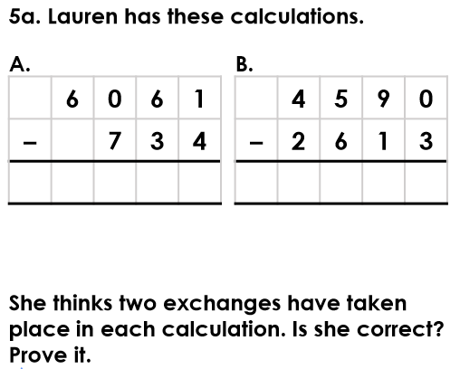 | Problem solving  