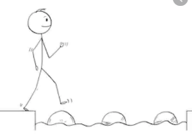
Year 4 Maths
Steppingstone activity
Lesson 4
LO: To subtract two 4-digit numbers
Success Criteria:
- Write out the calculation – check digits are in the correct columns!
- Subtract the bottom ones digit from the top ones digit.
- Subtract the bottom tens digit from the top tens digit.
- Subtract the bottom hundreds digit from the top hundreds digit.
- Subtract the bottom thousands digit from the top thousands digit.
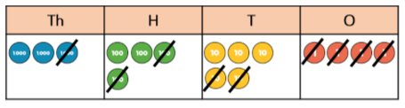
Model

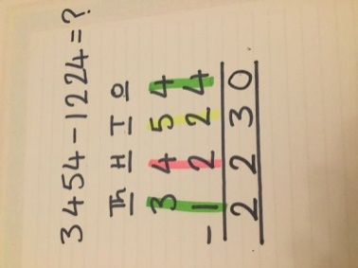
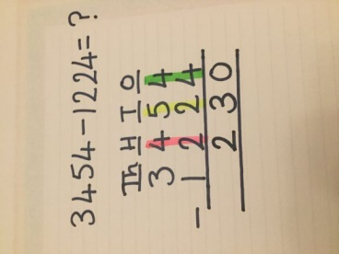
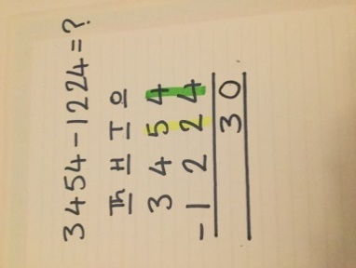
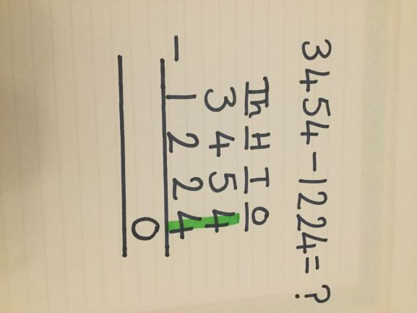
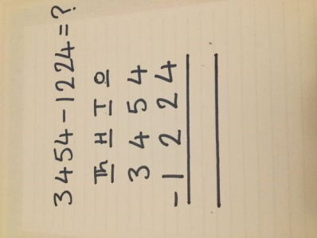
- 2. 3. 4. 5.

Now you try…

- 2. 3.
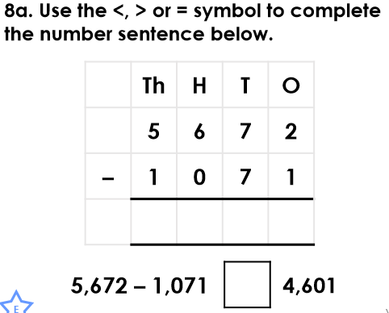
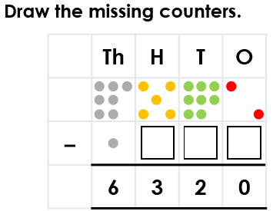
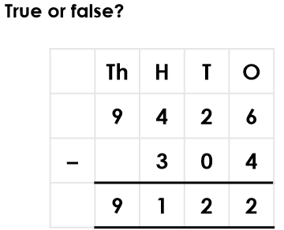

True 2 counters in the hundreds 4,601 = 4,601
column, 6 counters in the
tens column, 2 counters in
the ones column.

Year 4 Maths
Lesson 3
LO: To subtract two 4-digit numbers
Task:
You are going to practise subtracting with exchanges.
Success Criteria for 5643 - 4316
- Write out the calculation – check digits are in the correct columns!
- Can you subtract the bottom digit from the top digit? No. Exchange one ten for ten ones.
- Subtract the bottom one from the new 2-digit number above.
- Go to the tens column and subtract the bottom ten from the new top ten.
- Subtract the bottom hundreds digit from the top hundreds digit.
- Subtract the bottom thousands digit from the top thousands digit.
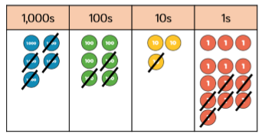
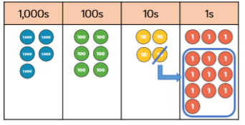
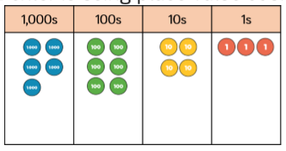
Model:

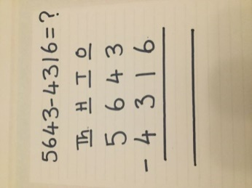
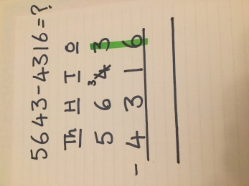
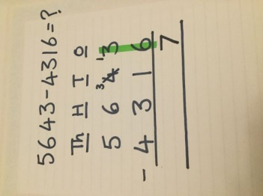
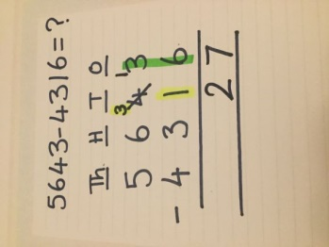
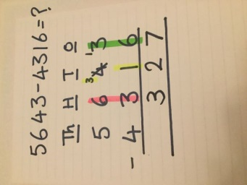
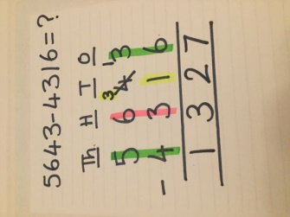
1. 2. 3. 4. 5. 6.

Make sure all your answers are in the correct columns!!!
Year 4 Maths
Main activity
Complete at least 2 columns, more if you can!
Task 1 | Task 2 | Task 3 | Task 4
Practice  Have a go at these subtractions (more than one exchange)  6741 – 3912 = 2829  5805 – 1943 = 3862  5237 – 5159 = 78  7016 – 1241 = 5775  3764 – 2829 = 935 | Practice  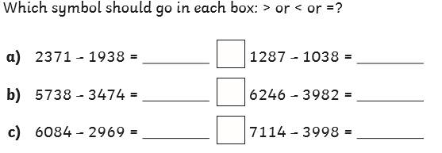  a) 2371 – 1938 = 433 > 1287 – 1038 = 249  b) 5738 – 3474 = 2264 = 6246 – 3982 = 2264  c) 6084 – 2969 = 3115 < 7114 – 3998 = 3116 | Reasoning  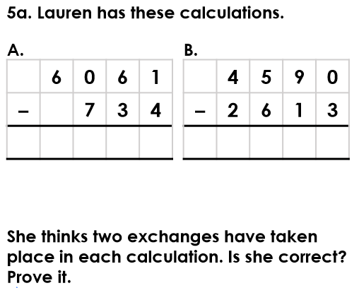  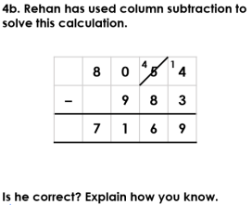  4b. Rehan is incorrect because he has exchanged from the tens incorrectly and he hasn’t exchanged from the hundreds. The correct answer is 7,071.  5a. Lauren is correct because two exchanges take place in the calculations (A: one in the thousands, one in the tens. B: one in the thousands, one in the tens) | 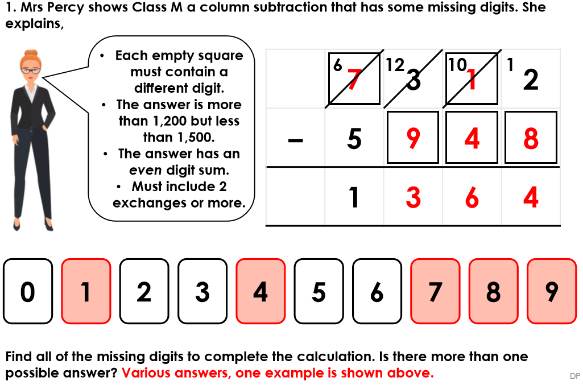  Problem solving

