Year 2 Maths
ANSWERS
Task 1 | Task 2 | Task 3 | Task 4
Practice  Use Base 10 jottings to answer these calculations:  26 + 17 = 43  37 + 24 = 61  34 + 29 = 63  48 + 16 = 64  54 + 37 = 91 | Practice  Use Base 10 jottings to answer these calculations:  39 + 22 = 61  32 + 48 = 80  54 + 39 = 93  52 + 31 + 18 = 91  50 + 36 + 35 = 121  55 + 26 + 61 = 142 | Reasoning  Explain your answers.  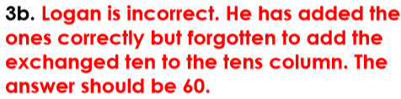 | Problem solving

