Task 1 | Task 2 | Task 3 | Task 4
Developing Task Answers  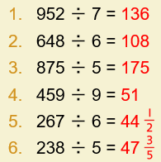  Practice  Have a go at these subtractions. Use the written method:  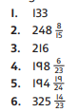 | Arithmetic  Have a go at these additions.  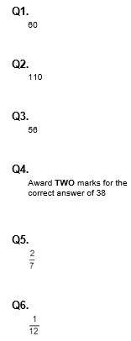 | Reasoning  Explain your answers.  Task 1  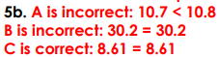  Task 2  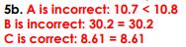 | Problem solving  Task 1  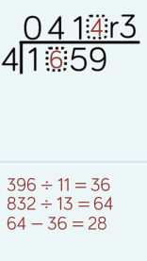  Task 2

