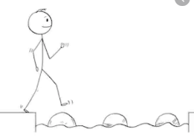
Year 3 Maths
Steppingstone activity
Lesson 4
LO: To order events in time – am and pm
Success Criteria:
- Look at the times on the timetable.
- Decide if the activity is done before 12 noon – if so write am
- Decide if the activity is done after 12 noon – if so write pm
- Write 4 more activities you do in am and 4 more you do in pm.
When we tell the time, to be clear if we are talking about morning or afternoon/evening, we use am or pm.
The first part of the day goes from 12 midnight to 12 noon.
We call this the morning and use am (a latin way of saying before noon) to show this.
The second part of the day goes from 12 noon to 12 midnight.
This is the afternoon and evening. We use pm to show this.
Model
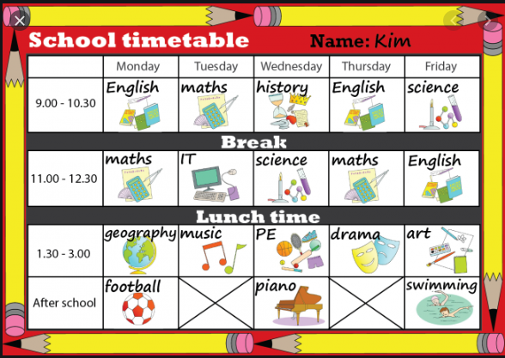
Now you try: Sort the activities from the timetable into those that Kim does in the morning (am) and those she does in the afternoon (pm). Then write at least 4 more activities you do in am and pm.
11.00 -11.50

Year 3 Maths
Lesson 4
LO: To use am and pm to describe time
Success Criteria:
- Organise the the times into am and pm
- Begin with am (morning times) and order the hours (e.g. 9.45) from smallest (earliest) to largest
- Do the same with pm (afternoon/evening times)
- Watch out! Any times between midnight and 1am will begin with 12 – these will be the very earliest!
Model
Sarah and Juliet arranged a meeting to Face Time today at 7.30.
How did they know whether to meet at 7.30 after breakfast or 7.30 after supper?
They needed to use am or pm to be clear what time of day they meant.

(They’re both early birds so they decided 7.30am was best!)

When we tell the time, to be clear if we are talking about morning or afternoon/evening, we use am or pm.
The first part of the day goes from 12 midnight to 12 noon.
We call this the morning and use am (a latin way of saying before noon) to show this.
The second part of the day goes from 12 noon to 12 midnight.
This is the afternoon and evening. We use pm to show this.

Now you try:
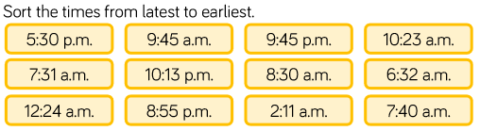

Year 3 Maths

Main activity
Complete at least 2 columns, more if you can!
Task 1 | Task 2 | Task 3 | Task 4
Practise  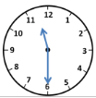  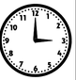  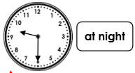  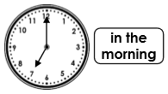 | Practise  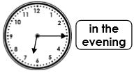  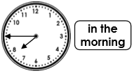  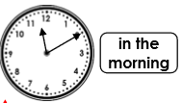 | Reasoning  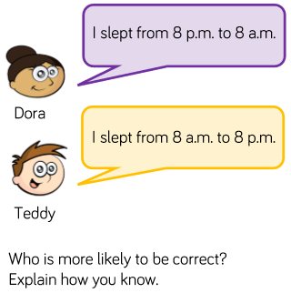  Steph and Sean are going on holiday. They need to be at the airport two hours before their flight.  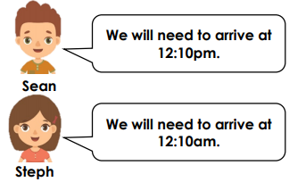  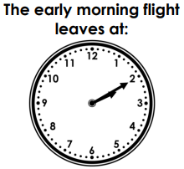  Who has the correct time?  Explain how you know. | 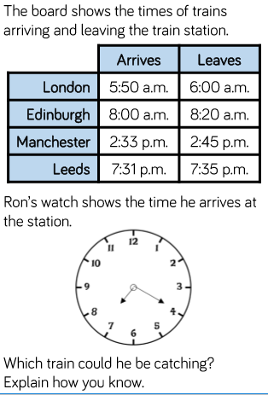Write down an activity you might do during the times listed below. Tick to show if the time is a.m., p.m. or both.  