Literacy: If you were a butterfly, where would you fly to? What places do you want to see the most? Draw some pictures of these places- maybe get up some different scenes on your phone for your child to look at. They may want to go to the beach, over a rainbow, to a castle or haunted house. Talk to your child about the different things they can see, what might they do there? Write down what they say and read it back to them, maybe they’d like to write a story about this place.

Physical: Tummy crawl: pretend to be a caterpillar,

Butterfly movement: flutter your arms, walk on tiptoes

Crab walk:start in sitting, lean back on both hands flat on floor, lift bottom up to make bridge; hold for 2-3 seconds and release

Bear walk: stomping with big steps

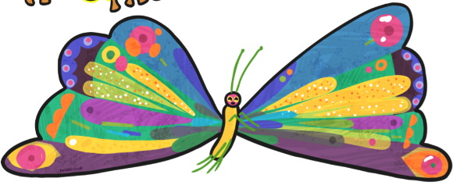

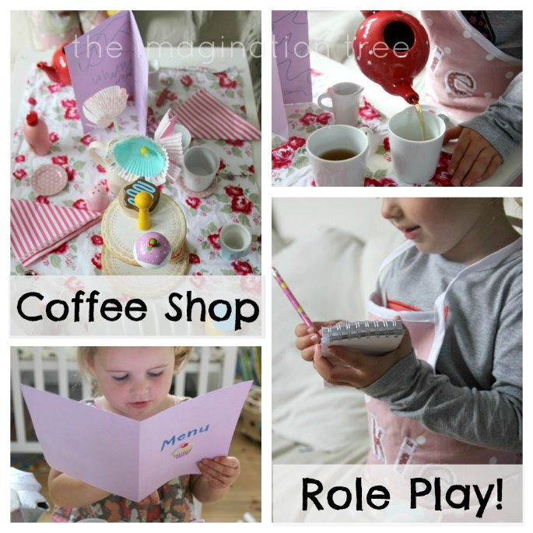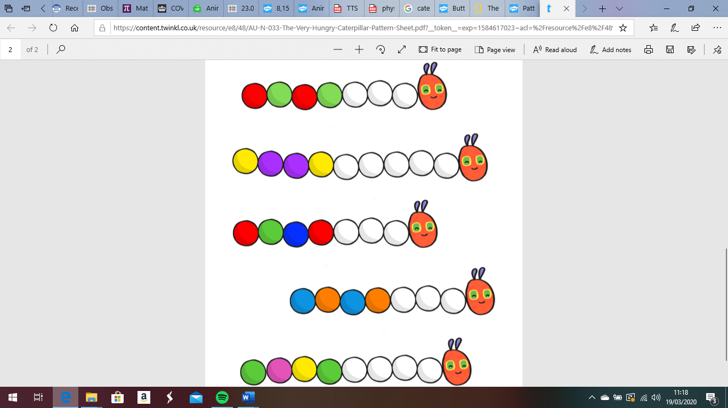[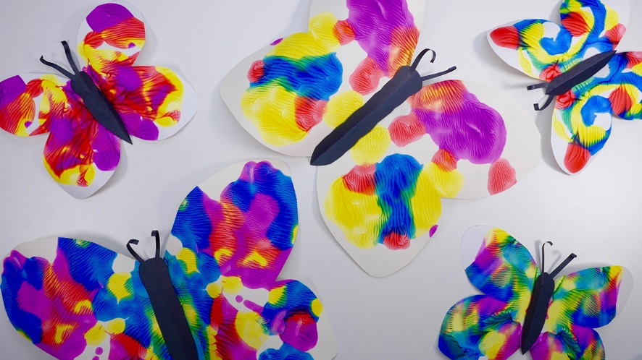](https://www.google.co.uk/url?sa=i&url=https://www.tes.com/lessons/DLe_9r0x5LYZ0A/copy-of-symmetry-butterflies-and-bugs&psig=AOvVaw2CbdmhEiYGUMww95AKrC8T&ust=1584702440583000&source=images&cd=vfe&ved=0CAIQjRxqFwoTCNjhjuKypugCFQAAAAAdAAAAABAn)

Song:

10 in the Bed… can you recreate this with your cuddly toys at home?

Phonics: Teddy is lost in the jungle…

A teddy bear is hidden somewhere in the room. You need to help your child to find the teddy by singing louder as the rescuer gets closer to, or quietly as the rescuer moves further away from the teddy. You could also speed up and slow down to guide them. If there’s more than two of you, one person must find the teddy, everyone else sings. Encourage your child to be the one to hide the teddy bear as well and you have to find it!

This week’s Expressive Arts and Design:

Can you make a pattern using a butterfly or a caterpillar picture? Draw the outline of one or the other (or both).

For the butterfly, give your child some paint to be able to paint one side of the butterfly. Try to encourage them to think carefully about detail, look at a picture of the butterfly to see the different colours and shapes. Can they paint some small circles or a variety of lines- wavy, straight, curved etc. Fold the paper to print the same pattern on the other side.

For the caterpillar, can they paint or draw

a repeated pattern using different colours

or different shapes along its body.

Maths: Set up a shop or café with the cuddly toys. Choose some food from the cupboard and write up a menu with your child- they may want to make some marks, but it is good for you to model writing to them as well.

You can write a list of food and then

next to it you can decide the currency.

What does each toy need to pay if they

would like an apple? You might want to

sell it in high fives (so write down how

many high fives you would need), or if

you have some counters you can count

those out like money. You could use

playdough pieces!