Year 1 Reading
Date: Thursday 26th March 2020
LO: To answer questions about a text
Success Criteria:
- Here is a part of a story from the book Winnie-the-Pooh by A.A. Milne
Read it
2. Talk about what you have read
3. Answer the Questions about it

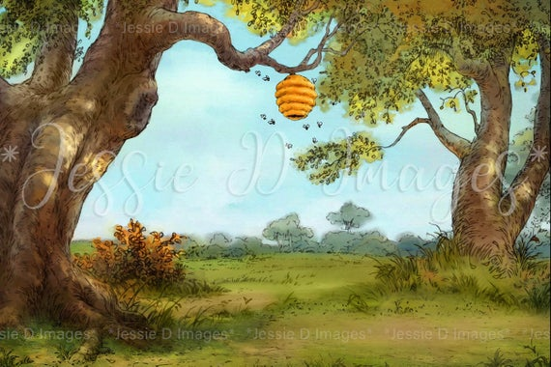

Winnie-the-Pooh sat down by tree thinking.

He heard a buzzing sound. What was making the buzzing sound? It must be bees.

What do bees make? Yummy honey for me!

He climbed the tree.

Questions

Where was Winnie-the-Pooh sitting?

What could he hear?

Do you think that he likes honey? Why?

What did he climb?

What do you think happens next? Draw a picture of what you think may happen next in the story?

Winnie-the-Pooh sat down at the foot of a tree, put his head between his paws, and began to think.

First of all he said to himself “That buzzing noise means something. You don’t get a buzzing noise like that, just buzzing and buzzing, without it meaning something. If there’s a buzzing noise, somebody is making a buzzing noise, and the only reason for making a buzzing noise that I know of is because you’re a bee.”

Then he thought another long time, and said “And the only reason for being a bee that I know of is making honey.”

And then he got up, and said “And the only reason for making honey is so I can eat it.” So he began to climb the tree.

He climbed and he climbed and he climbed, and...

Questions
- Where was Winnie-the-Pooh sitting? ______________________________

- What part of the tree is this? ______________________________________

- What was he doing there? _______________________________________

- What could he hear?_____________________________________________

- Why did he decide to climb the tree? _____________________________

__________________________________________________________________

- What does Winnie-the-Pooh like to eat? ___________________________

- What do you think may happen next? Draw a picture to show what you think may happen next in the story.

_______________________________________________________________________________________________________________________________________________________________________________________________________________________________________

