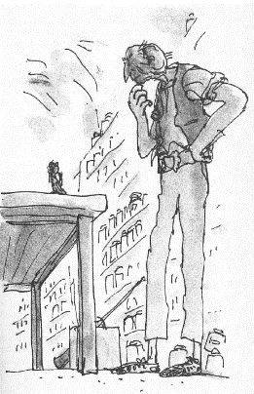
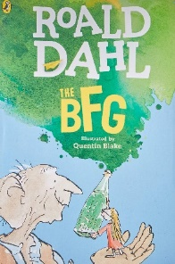
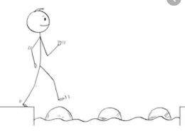
Year 4 Reading
Steppingstone activity
Task:
Share the next chapter of the BFG with an adult or older sibling- ‘The BFG’.
This chapter is where we meet the BFG properly and find out a bit more about him. He doesn’t speak in the same way as Sophie!
Your task is to retrieve some key information from the first page of the chapter as speedily as possible! Time yourself!
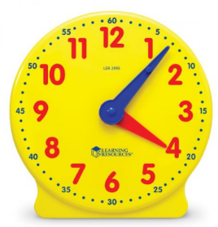

Speedy retrieval!

What did the giant place Sophie on top of? | What did Sophie think? | Describe the giant’s ear:
Describe the giant’s teeth: | Write down something the giant says: | What is a bonecruncher?
What does the sound of humans being eaten sound like? | What do humans from Turkey taste like? | What do humans from Greece taste like?

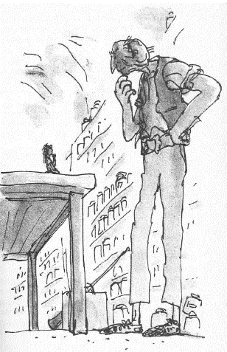
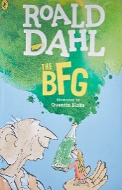
Year 4 Reading
Date: Thursday 26th March 2020
LO: To retrieve key information
Task:
Read the next chapter of the BFG- ‘The BFG’.
This chapter is where we meet the BFG properly and find out a bit more about him. He doesn’t speak in the same way as Sophie!
Your task is to retrieve some key information from the text as speedily as possible! Time yourself!

Speedy retrieval!

What did the giant place Sophie on top of? | Write down 2 things about the Giant’s appearance: | What is the first thing the Giant says to Sophie?
Where are Sophie and the BFG now? | What is a bonecruncher? | How many humans can they eat a night?
How does the giant describe the noise of eating humans? | Why do bonecrunching giants prefer humans from Turkey? | What do humans from Panama taste like?
Name 3 more human flavours: | Does the BFG eat humans? | What does BFG stand for?

