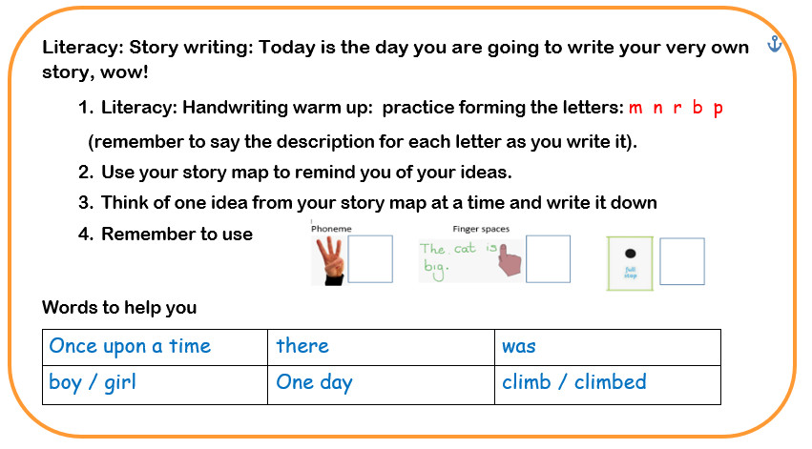

This week’s

Expressive Arts and Design

Make an Easter Card for someone in your family as a nice surprise!

Song: Tricky Word Song

<https://www.youtube.com/watch?v=TvMyssfAUx0>

Maths: Half and double

Scroll down to play the board game (below the phonics).

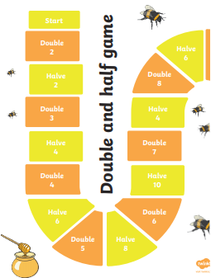

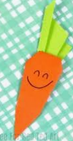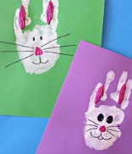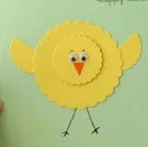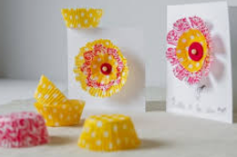

**Phonics: It’s time for those tricky old red words**

The red words children need to know by the end of Reception year are:

|  |  |  |
| --- | --- | --- |
| Phase 2 | Phase 3 | |
| I  no  go  to  into  the | he  she  we  me  be  you | are  her  was  all  they  my |

Red words are a set of words that we do not sound out as they do not follow the pattern of phonics the children are learning to use; so, practise sight reading these words at home.

Ideas that can help could include:

* Write the words on pieces of card (this could be an old cereal box cut up) and use them as flash cards.
* These cards could also be turned face down to make up a game of memory
* Why not make twice as many cards and play a game of snap
* Watch out for them in story books and count how many there are; I wonder whether there is a particular word that is used more than others?

If you feel your child is ready for more of a challenge, then begin to learn to spell the words. This can be using the Look, Cover, Check, method i.e.

<https://www.twinkl.co.uk/resource/t-l-4758-phase-3-tricky-words-on-writing-practice-worksheets>

