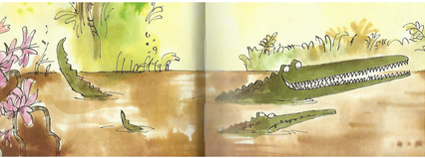
Year 3 Writing
Lesson 4
LO: To identify opportunities to include adjectives in story writing
Task:
Read on from P21 (meeting the monkey) to P26 (It won’t be long before I am eating the first part of my lunch). NB the page numbers of my copy of the book might not exactly correspond with yours.
Remind yourself of what an adjective is (a word that describes a noun E.g. the small, cheeky monkey jumped from branch to branch.)
Often you include more than one adjective to describe a noun so you need to remember to include commas in a list.
Look again at this section of the story that describes meeting the Roly-Poly bird. Can you find the adjectives that describe these nouns? Write them in a list:
plans | tricks | fish | tail feathers
Choose some nouns from the book to describe, using powerful adjectives. Write a short description of each one that you choose. You will use several nouns in each description so try to include as many great adjectives as you can. Try to write at least 5 short descriptions. It would be great if you did some illustrations to help you imagine what you are describing.
Success Criteria:
- Choose nouns from the book to describe.
- Remember that a proper noun must start with capital letter.
- Write at least 5 short descriptive paragraphs that include some of your chosen nouns.
- If you use several adjectives in a list, remember to include commas.
- Re-read your sentences/paragraphs to check they are correctly spelt, punctuated and make sense.
Word bank: (you do not have to choose these nouns- they are just a suggestion)
Enormous Crocodile | Muggle-Wump | Roly-Poly Bird | river | jungle
Trunky Elephant | Notsobig One | feathers | teeth | child
Example:
The scaly, menacing crocodile crept slowly forward through the jungle like a sloth. His terrible, razor-sharp teeth glinted like rusty daggers in the yellow sunshine. He slipped into the river like a rotten old log and floated along the muddy river waiting for his chance to pounce.

Extra challenge (optional):
Try to include some metaphors or similes in your short descriptions.

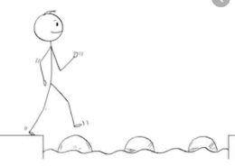
Year 3 Writing
Steppingstone activity
Lesson 4
LO: To use adjectives and nouns
Task:
Share the next part of the book with an adult or older sibling again up to the end of the section of the story that describes meeting the Roly-Poly bird (up to It won’t be long before I am eating the first part of my lunch).
Remind yourself of what a noun is (name of objects in the sentence: E.g. The Enormous Crocodile laughed out loud.
An adverb is an extra word to describe how the action is done. E.g. The nasty, horrible crocodile laughed out loud.
You need to draw some objects or characters from the story and write a sentence beneath each picture that includes a noun and an adjective to describe it.
Try to do at least 4 pictures and sentences.

Success Criteria:
- Choose things in the story (nouns).
- Draw the objects, characters or things you want to describe.
- Write a sentence to name and describe each picture.
- Make sure you include an adjective in each sentence.

Word bank: (you do not have to choose these nouns- they are just a suggestion)
crocodile | monkey | elephant | bird

Example:
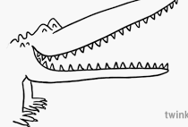

The ugly crocodile hard sharp, dangerous teeth.

