Year 4 Writing
Lesson 4
LO: To describe a character’s feelings
Task (with links):
Watch this video clip: https://www.literacyshed.com/takingflight.html
Also on: https://www.youtube.com/watch?v=Gj6V-xZgtlQ ‘Taking Flight’
We want you to empathise with our main characters: Grandpa and Tony. For each moment, write a sentence describing how the characters feels.

Year 4 spelling words: Can you include ‘–tion’, ‘-sion’, -‘ssion’, ‘-cian’ words? Possession, attention
Feelings
Upset Miserable Confused Scared Confusion Curious Nervous Excited Thrilled
Surprised Astonished
Success Criteria:
- Look at the picture
- Write a sentence about Tony’s feelings
- Write in the third person
- Use ‘because’ for your reason

Scene | Feelings:  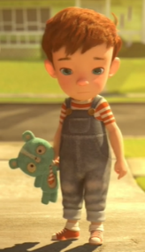Tony | Feelings:  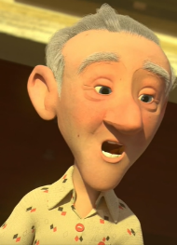Grandpa
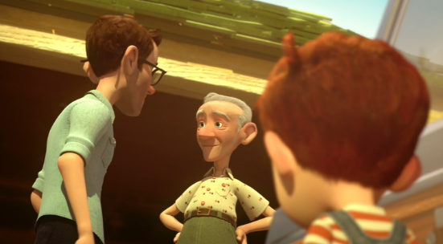  1 | Tony feels upset  because…. | Grandpa feels relaxed  because….
2
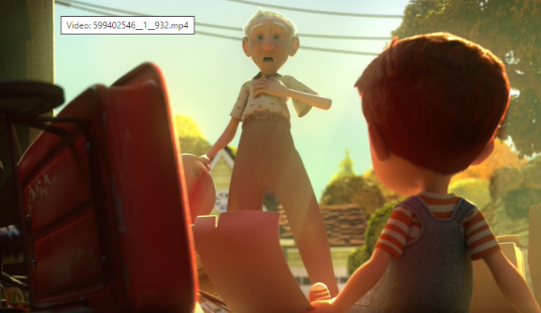
3
4
5
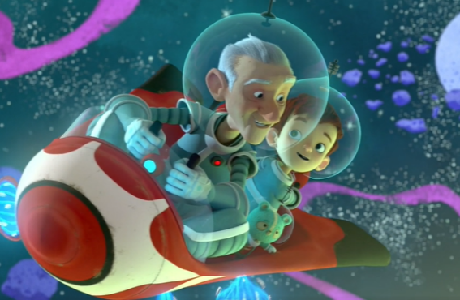
6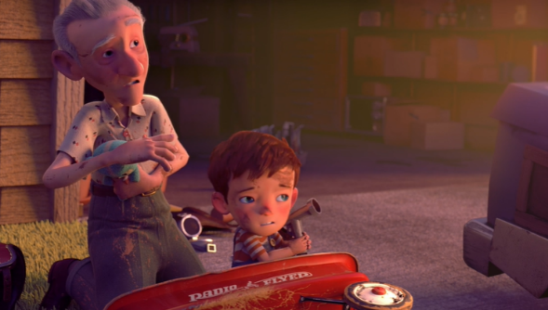

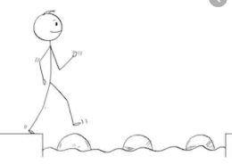
Year 4 Writing
Steppingstone activity
Lesson 4
LO: To describe a character’s feelings
Year 4 spelling words: Can you include ‘–tion’, ‘-sion’, -‘ssion’, ‘-cian’ words? Possession, attention
Task (with links):
Watch this video clip: https://www.literacyshed.com/takingflight.html
Also on: https://www.youtube.com/watch?v=Gj6V-xZgtlQ ‘Taking Flight’
We want you to empathise with our main character: Tony. For each moment, write a sentence describing how the character feels.
Feelings
Upset Miserable
Curious Nervous
Excited Thrilled
Surprised Astonished
Confused Scared
Confusion
Success Criteria:
- Look at the picture
- Draw an emoji for Tony’s feelings
- Write a sentence about Tony’s feelings
- Write in the third person

Main Idea for the Paragraph | Emoji | Feelings:
1 |  | Tony feels…  because…
2
3
4
5

6

