Year 4 Maths
Lesson 5
LO: To carry out a maths investigation
Complete one of these investigations, more if you want to!
Task 1 | 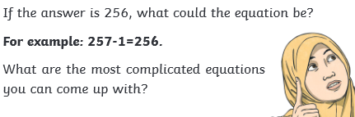
Task 2 | 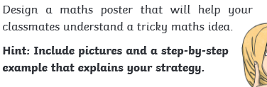
Task 3 | 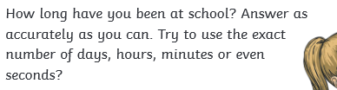
Task 4 | 