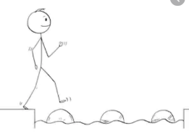
Year 3 Maths
Steppingstone activity
Lesson 5
LO: To order events in time – am and pm
Success Criteria:
- Think of at least 6 things you do each day (or what you did yesterday)
- Draw a picture of each of them in the order you did them
- Write the time you did them underneath, using am for morning and pm for afternoon/evening
- Extension: Draw a clock to show the time too.

Model
Put your knowledge of time into practise today:
Create a diary using pictures to show your day from waking up to going to bed.
Label these events using the 12-hour clock and saying am or pm.
E.g.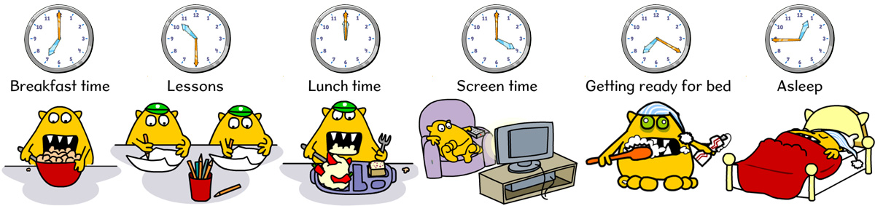
7.00am | 10.30am | 12.00pm (noon) | 4.00pm | 7.20 pm | 12.45am

Year 3 Maths
Lesson 5
LO: To tell the time using 24 hour clock
Success Criteria:
- Think of at least 6 things you do each day (or what you did yesterday)
- Draw a picture of each of them in the order you did them
- Write the time you did them underneath, using 24 hour clock
- Extension: Draw a clock to show the time too
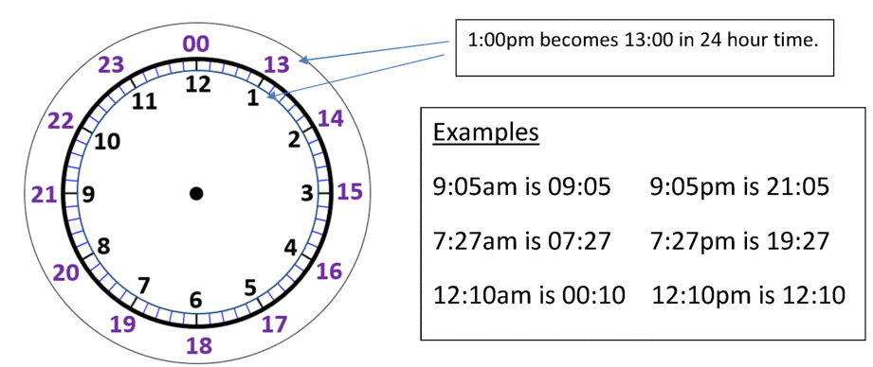
Model
The 24 hour clock does not have am and pm times.
To change an am time to a 24 hour time, you don’t need to do anything unless it is 12am in which case the hour changes to 00. Add a zero before a single digit hour e.g. 03.45.
To change a pm time to a 24 hour time, just add 12 to the hour, unless it is 12pm (noon). This time does not change.

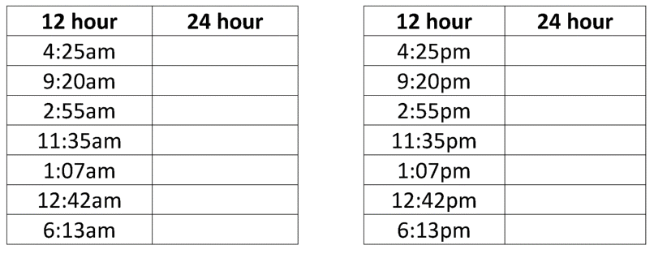
Now you try:

Year 3 Maths
Main activity
Create a diary using pictures to show your day from waking up to going to bed.
Label these events using the 24 hour clock .
Draw clock to show the times too.
E.g.
07.00 | 10.30 | 12.00 | 16.00 | 19.20 | 00.45

