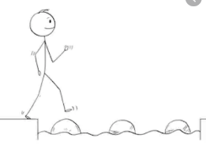
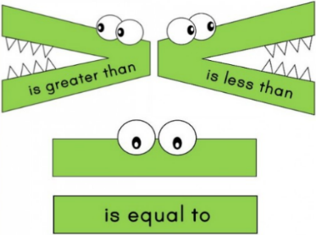
Year 2 Maths
Steppingstone activity
Lesson 5
LO: To order numbers to 50
Success Criteria:
- Look at the representations
- Complete the statements in your exercise books
1. Use the images to complete the statement: | 2. Use the images to complete the statement: | 3. Complete the sentences below:  The group with the most has _____.  The group with the least has _____.
4. Use the groups to complete the statement: | 5. Use the digit cards to complete the statement below: | 6. Use the digit cards to complete the statement below:

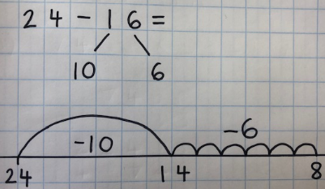
Year 2 Maths
Lesson 5
LO: To subtract two 2-digit numbers
Task:
You are going to be using partitioning and number lines for subtraction with exchange
Success Criteria:
- Write the number sentence, leaving the answer blank e.g. 24 - 16 =
- Partition the number that you are subtracting (e.g. 24 - 16 =) into tens and ones
- Start a number line from the first number (e.g. 24 - 16 =)
- Make your tens jumps (e.g. 24 - 16 = one jump of ten from 24) and mark the numbers on the number line
- Make your ones jumps (e.g. 24 - 16 = six jumps of one from 14) and mark the number on the number line
- Write the final answer after your number sentence e.g. 24 - 16 = 8

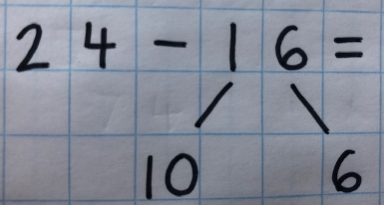
Model:
2.
3.
1.
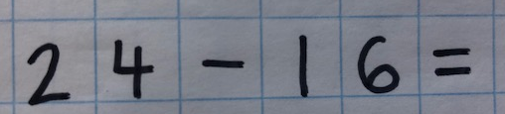

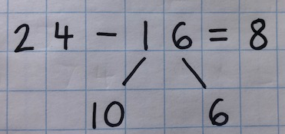
6.
4.
5.

Year 2 Maths
Main activity
Complete at least 2 columns, more if you can!
Task 1 | Task 2 | Task 3 | Task 4
Practice  Use a number line to subtract these  2-digit numbers:  26 - 17 =  24 - 15 =  31 - 23 =  44 - 26 =  62 - 39 = | Practice  Use a number line to subtract these  2-digit numbers:  25 - 19 =  56 - 37 =  74 - 26 =  98 - 39 =  107 - 48 =  151 - 56 = | Reasoning  Explain your answers.  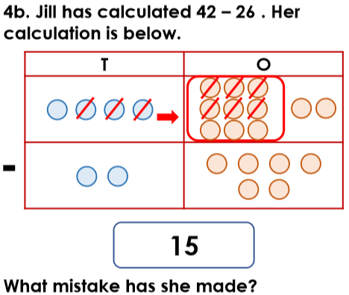  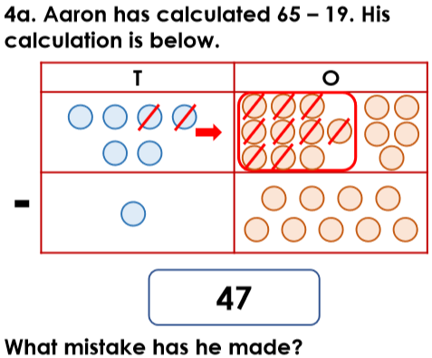 | 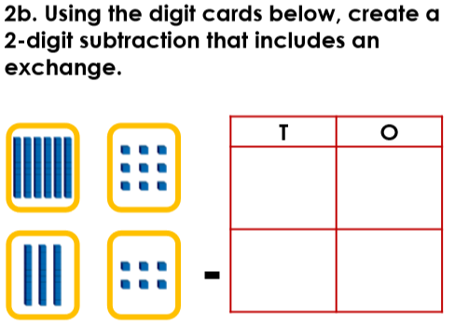  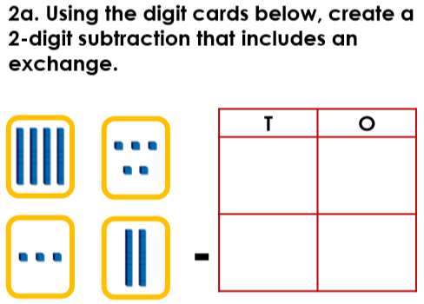  Problem solving

