Year 6 Maths
Developing activity
Lesson 5
LO: TBAT identify factors.
Success Criteria:
- Apply your knowledge of multiplication to find factor pairs for a multiple.

Model
Now you try…
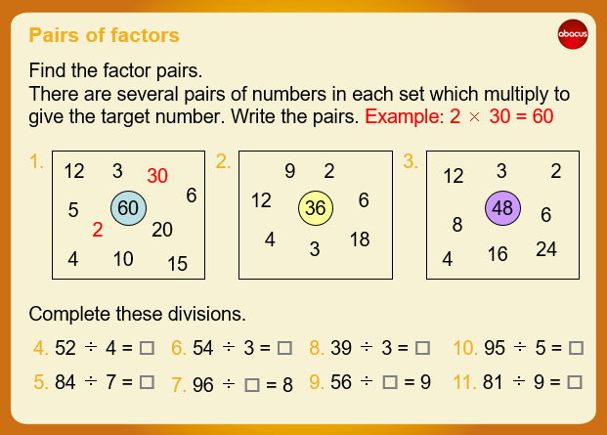
In your exercise book, write pairs of factors which make the numbers in the circles.
For example…
18 x 2 = 36
Which other sums can you create?
Year 6 Maths
Expected/ Greater depth activity
Lesson 5
LO: TBAT use division in a range of contexts.
Task:
You are going apply your knowledge of factors to solve several problems.
Success Criteria:
- For written methods ensure your layout is correct.
- When dividing with decimals ensure your answers also have decimals.
- When dividing fractions, divide the numerator and keep the denominator the same.

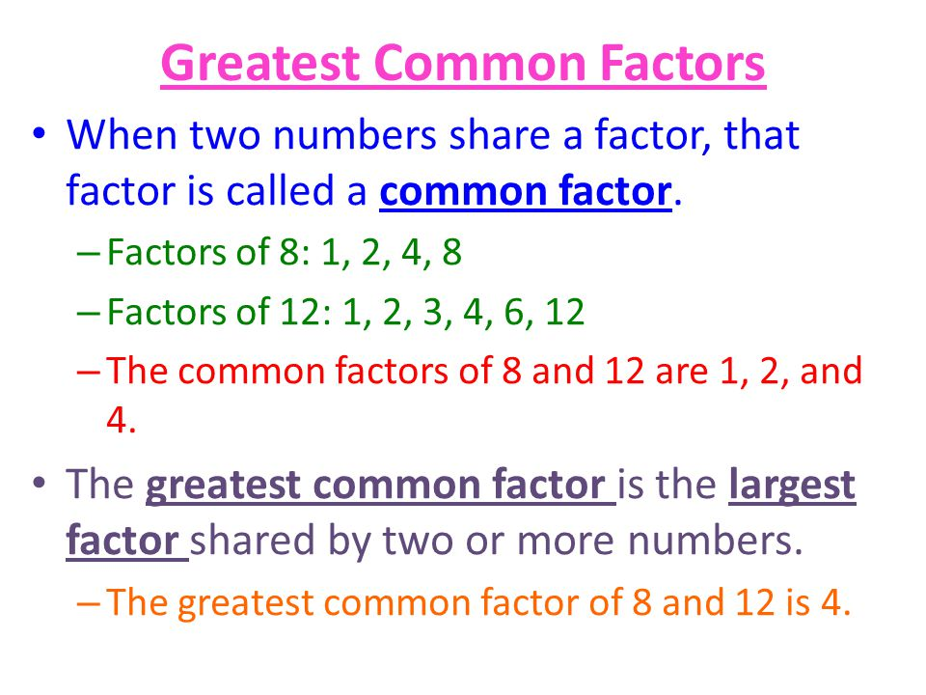
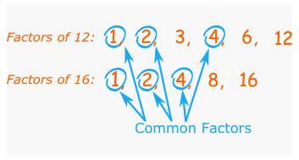
Recap:
Year 6 Maths
Main activity
Complete at least 2 columns, more if you can!
Task 1 | Task 2 | Task 4
Practice  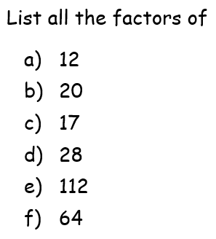  Have a go at finding the factors.  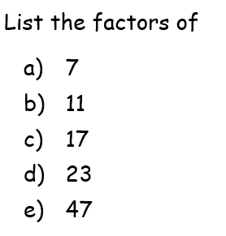  What do you notice about these numbers? | Reasoning  Explain your answers.  - Write three factors of 30 that are not factors of 15  - Complete this sentence.  Every number with a factor of 10 must also have factors of  - Here are four number cards.  Which two number cards are factors of 42? | Problem solving  Task 1  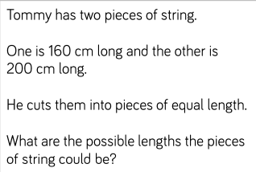  Task 2  