Year 5 Maths
Steppingstone activity
Lesson 5
LO: To divide 4 digit by 1 digit numbers with remainders
Success Criteria:
- Draw the ‘Bus stop’
- Start by dividing the thousands by the divisor and carrying any remainders
- Now divide the 100’s
- Now divide the 10’s
- Now divide the 1’s.
- Any amount left over is your remainder.

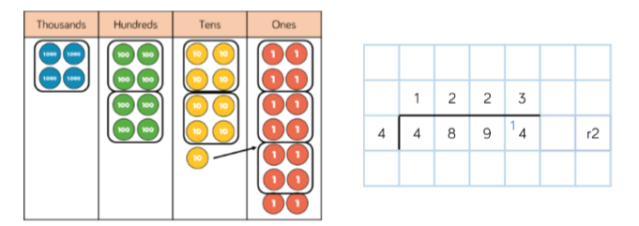
Model

Now you try…
6,613 ÷ 5 = 2,471 ÷ 3 = 9,363 ÷ 4 =

Year 5 Maths
Lesson 5
LO: To divide 4 digit by 1 digit numbers with remainders
You are going to continue practising Division!
Success Criteria:
- Draw the ‘Bus stop’
- Start by dividing the thousands by the divisor and carrying any remainders
- Now divide the 100’s
- Now divide the 10’s
- Now divide the 1’s.

Model:
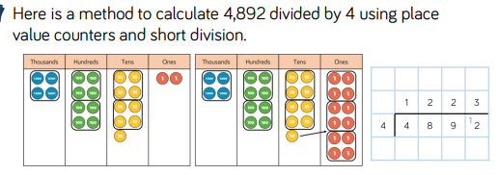

Make sure all your answers are in the correct columns!!!
Year 5 Maths
Main activity Lesson 5
Using the same method try these problems – remember to show your working out to prove your answer!
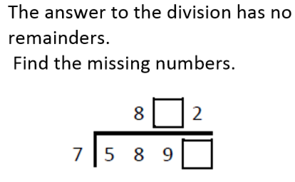
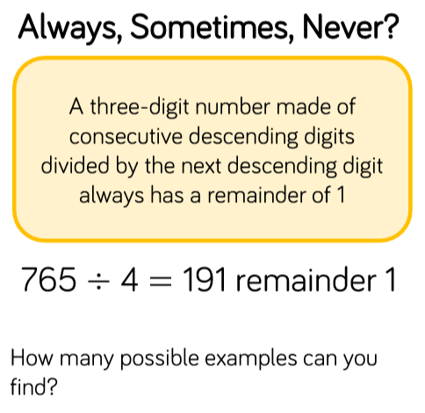

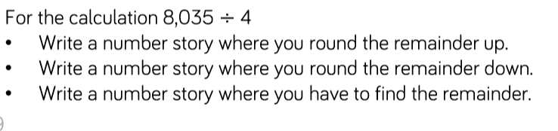

Ext- Complete any questions on the grid you didn’t finish yesterday!

