Literacy: Have a look at some stories and on the internet at your favourite insect. Think about making a book about it, take the time to show your child how to fold paper to make a book and think about different ways you could hold all the pages together. (You may have to be very creative if you don’t have a stapler or treasury tags!) Give your child some pictures to draw and then you can write their favourite facts about the insect inside. Where might they find that insect (water, land, England, Africa?) Can they fly or jump? Can they

change colour or shape? Cbeebies have some great

insect clips- I will put them on Tapestry!

Physical: Try Change4Life’s website <https://www.nhs.uk/10-minute-shake-up/shake-ups/jack-jacks-super-shapes>

Choose one person to be the leader and everyone lines up behind them. The leader sets off walking. Every few steps, they shapeshift into a move that everyone in the line has to copy, like a star jump, press-up, running on the spot or a dance move. Try to come up with as many different ones as you can! Continue for 10 minutes.

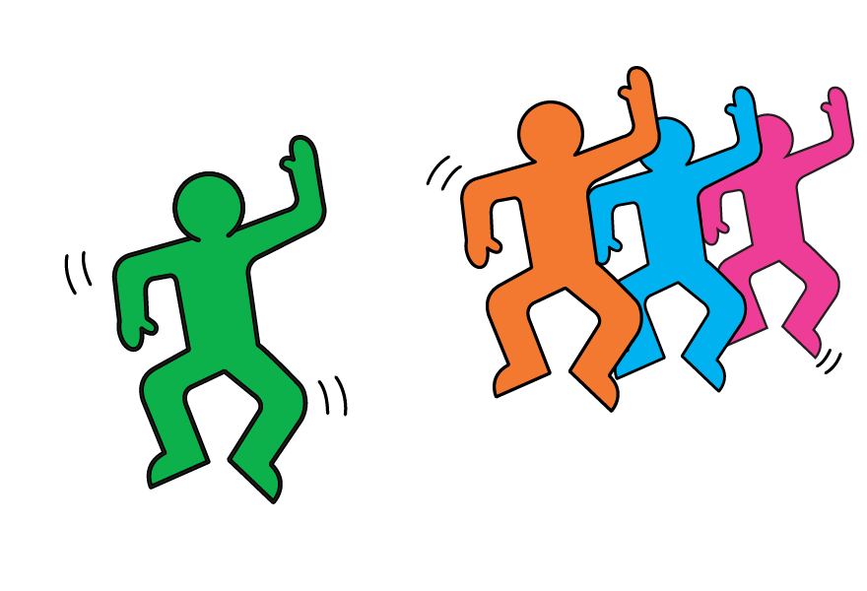

3

After 10 shapeshifts, the leader goes to the back of the line and the new leader starts shapeshifting.

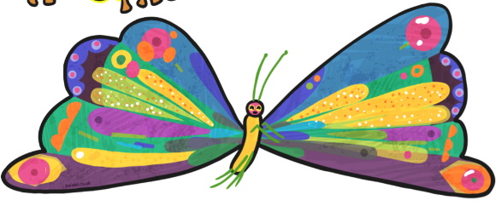

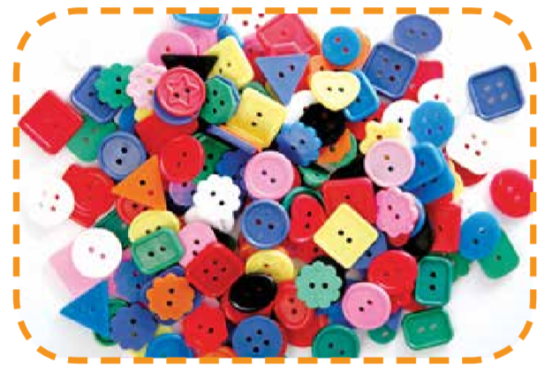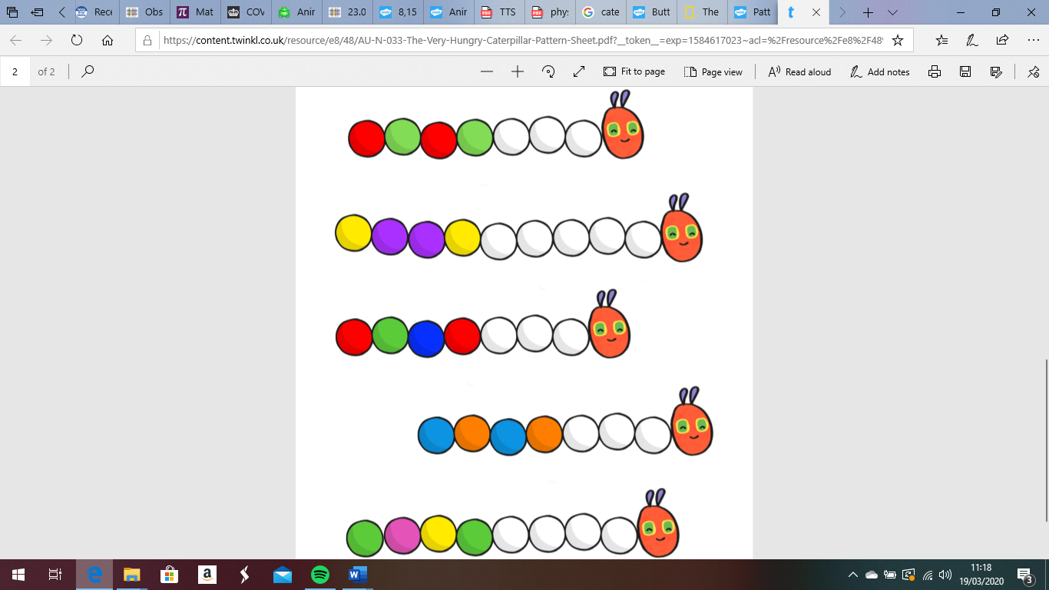[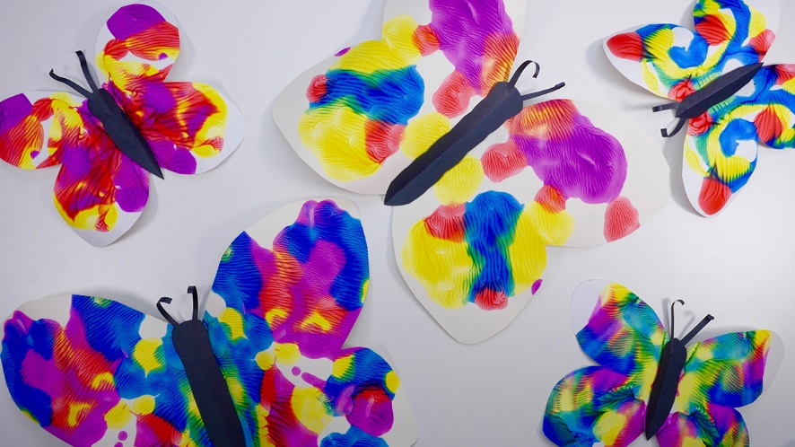](https://www.google.co.uk/url?sa=i&url=https://www.tes.com/lessons/DLe_9r0x5LYZ0A/copy-of-symmetry-butterflies-and-bugs&psig=AOvVaw2CbdmhEiYGUMww95AKrC8T&ust=1584702440583000&source=images&cd=vfe&ved=0CAIQjRxqFwoTCNjhjuKypugCFQAAAAAdAAAAABAn)

Maths: You may have a collection of buttons, pegs, pens, crayons, play animals, etc. Find containers for your child to sort into. Look carefully at what you are sorting. For example, can you put all the same shapes together? Or, could you sort by:

-Size? -Material? e.g. metal, plastic, wooden -Colour? -Animal? -Shape?

Buttons can look very similar but are they really, when you take a closer look, do they have the same number of holes? It might even be that you sort all the tins in the cupboard. Can you find all the soup tins, the tins of tomatoes and group them together?

You may wish to count out different amounts.

It is great if you make sure to touch the

item as they say the amount with you. There

are so many things you could count.

How many chairs, cushions, spoons, etc?

Song:

The Grand Old Duke of York- can you use your teddy to go up and down a hill (maybe made of boxes or the sofa?)

Phonics: Use your teddy to hide in a box or on the bed! As the adult, reiterate language such as where is teddy hiding? Is teddy inside the box? Is teddy on top of the box? Or ask them to put teddy in certain places next to, underneath, in front of, behind the box.

If this is too easy, see if they can tell you where to put the teddy. You could also make an obstacle course and your child needs to tell you what to go over or under to get to the teddy!

This week’s Expressive Arts and Design:

Can you make a pattern using a butterfly or a caterpillar picture? Draw the outline of one or the other (or both).

For the butterfly, give your child some paint to be able to paint one side of the butterfly. Try to encourage them to think carefully about detail, look at a picture of the butterfly to see the different colours and shapes. Can they paint some small circles or a variety of lines- wavy, straight, curved etc. Fold the paper to print the same pattern on the other side.

For the caterpillar, can they paint or draw

a repeated pattern using different colours

or different shapes along its body.