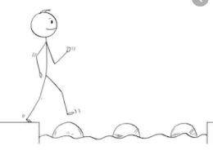
Year 4 reading
Friday 27th March 2020
Steppingstone activity
LO: To retrieve key information
Questions:
- Who caused the fire?
- What was one of the pigs wearing?

- What happened to the pedometer?
- What metal reacted with the pig poo?
- Who put out the fire?
Task: Share this news article with an adult or older sibling and answer the questions.
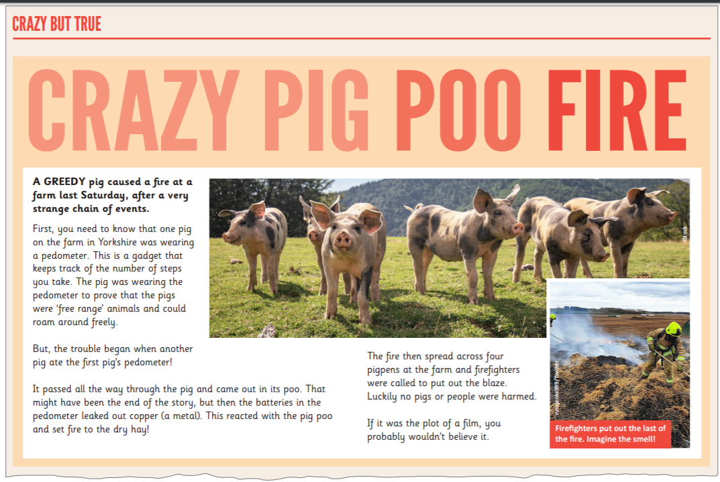

Year 4 reading
Friday 27th March 2020
LO: To use all of my comprehension skills
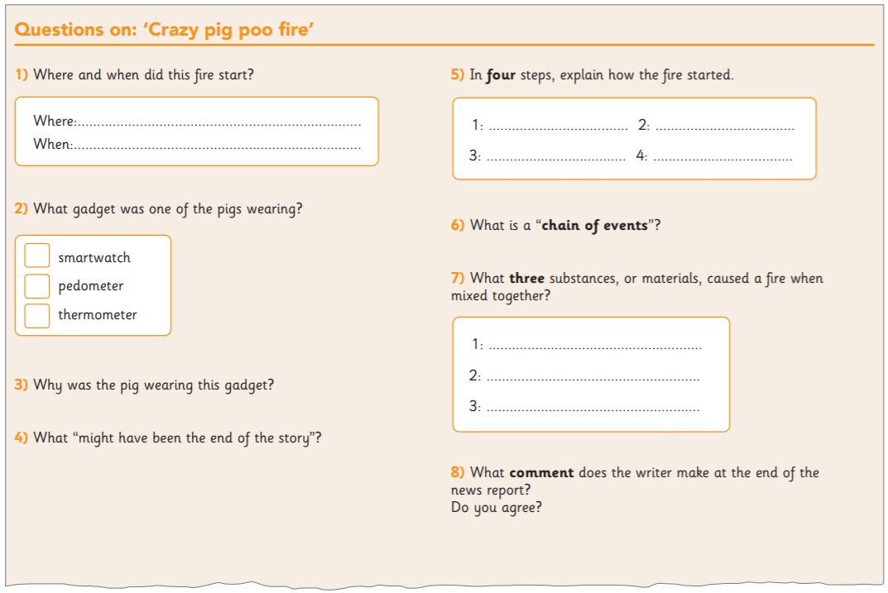
Task: Read this news article and answer the questions attached.
Questions:

