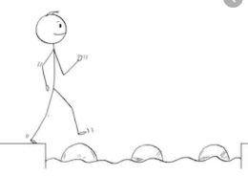
Year 2 Reading
Steppingstone activity
Date: Friday 27th March 2020
LO: To make inferences based on images
Reading Skill: Inference
Success Criteria:
- Look at the picture.
- Write the things you can see in the picture.

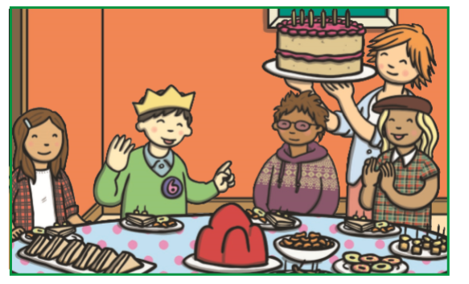
Challenge: Write a sentence to describe what the children are doing.

Year 2 Reading
Date: Friday 27th March 2020
LO: To make inferences based on images
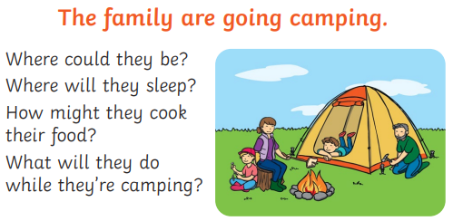
Reading Skill: Inference

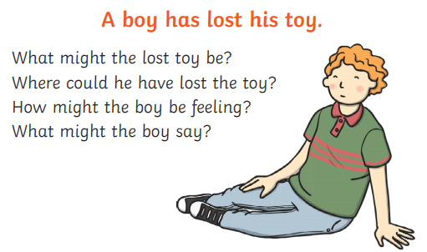

Success Criteria:
1. Read at the statements.
2. Read each question.
3. Write your inferences in your books and give sensible reasons.
4.Read your questions back
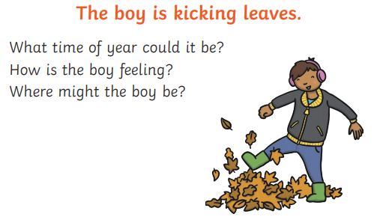
Challenge: Answer the questions below.

