Year 5 Reading
Lesson 5
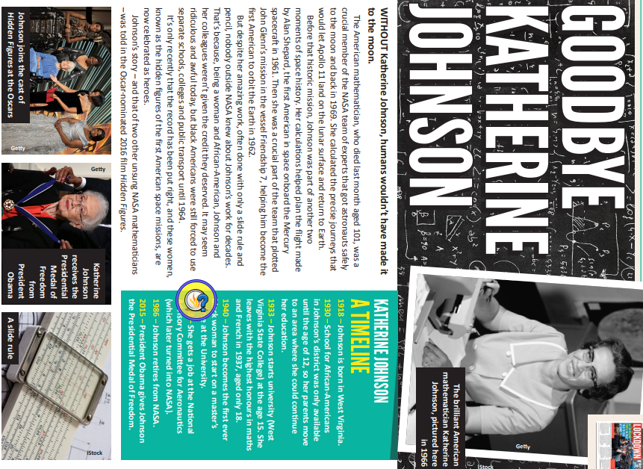
Activity: Complete the First News Comprehension.

