Literacy:

1. Handwriting warm up: practice forming the letters c a d g o s

(remember to say the description for each letter as you write it).

1. Today is the best day! Today you get to write your ‘Jack and the Beanstalk’ story! Write it in your yellow writing books and don’t forget to use your phonic mats to help you sound out the words you want to use
2. Remember also to think about : 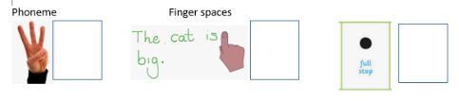

Once upon a time, there was a …

Physical: Make a mini ladybird using playdough and/or any materials in your home.

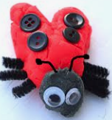

This week’s

Expressive Arts and Design

Make the Giant’s castle. You can use any materials that you have in your house. You can draw or use old boxes. You could use lego or even cut up pictures from magazines. You choose! Take a picture and put it on Tapestry.

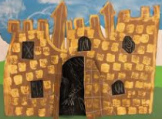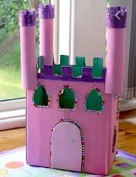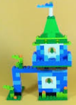

Song 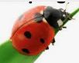

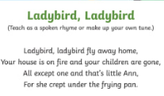

Maths: **Double and half**

Sign up for a free Twinkl account and look at the ladybird doubles resources

<https://www.twinkl.co.uk/resource/t-c-254566-ladybird-doubles-to-20-powerpoint>

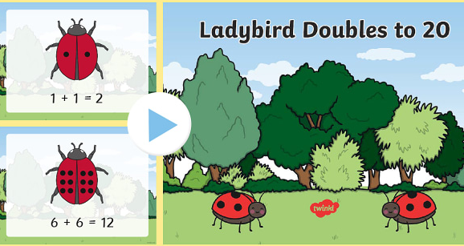

Can you spot how doubles and halves relate to each other?

Double 3 is 6, half of 6 is 3 etc.

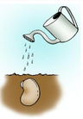

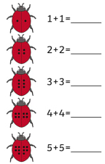

**Phonics – choose the one you need to learn next or have a go at them all.**

Revisit all the sounds covered so far on your phonics sheet and play this ‘I Spy’ game:

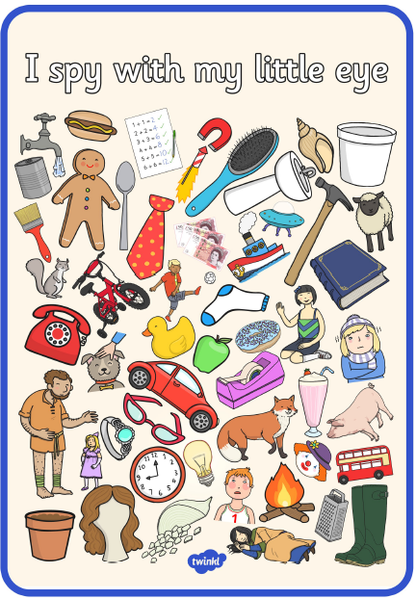

Phonics Play- Flash Cards Speed Trial

<https://www.phonicsplay.co.uk/Phase2Menu.htm>

Revise all the sounds:

Mmmm – Maisie, mountain, mountain

and so on…

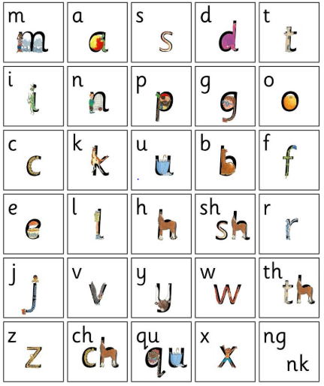

Hear the difference:

oo poo at the zoo oo look at a book

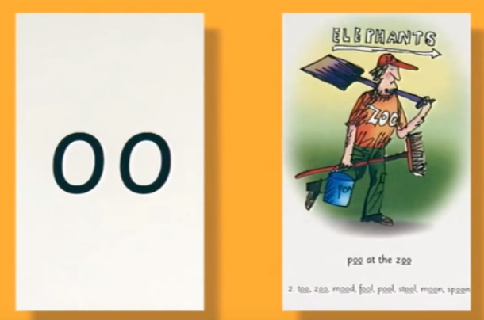 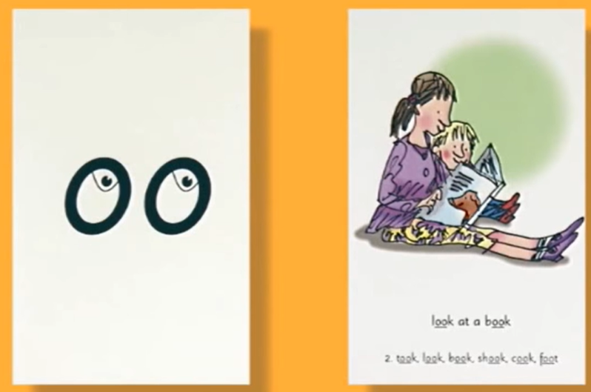

Click on Phase 3 and the oo sound. Sort words into real (treasure) and made-up (bin).

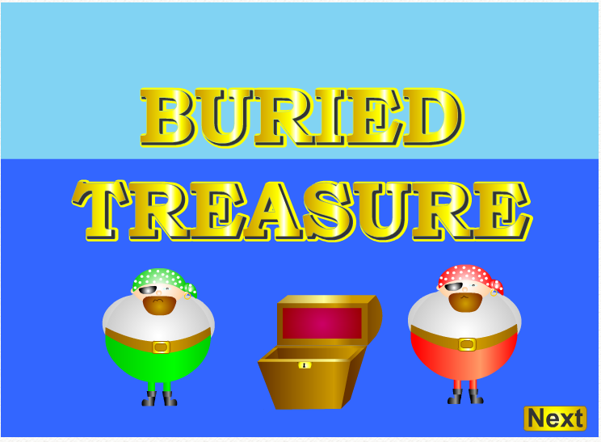<https://www.phonicsplay.co.uk/>

Use your dice to play this game. Place a counter over each word when you have read it.

