Literacy:

1. Handwriting warm up: practice forming the letters: m n r b p

(remember to say the description for each letter as you write it).

1. Read your story out to a grown up or act it out with your finger puppets.

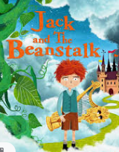

Physical: Make an Easter Egg out of playdough. Hide something small inside and try to find it.

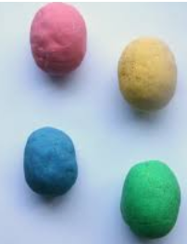

This week’s

Expressive Arts and Design

Make an Easter Card for someone in your family as a nice surprise!

Song: Hop Little Bunnies

Maths: Doubles game

Scroll down for the board game (below phonics) OR play online: <https://www.topmarks.co.uk/PlayPop.aspx?f=dartboarddoublesandhalves>

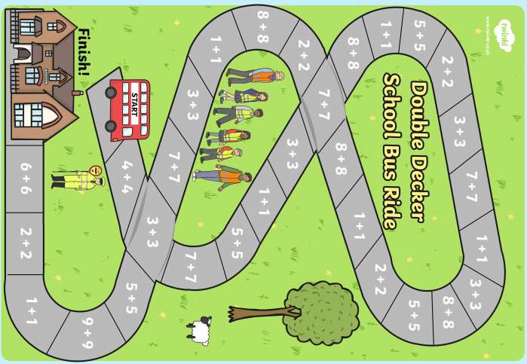

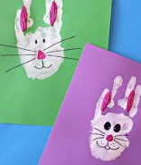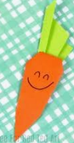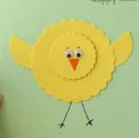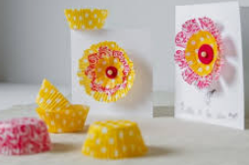

**Phonics: It’s time for those tricky old red words**

The red words children need to know by the end of Reception year are:

|  |  |  |
| --- | --- | --- |
| Phase 2 | Phase 3 | |
| I  no  go  to  into  the | he  she  we  me  be  you | are  her  was  all  they  my |

Red words are a set of words that we do not sound out as they do not follow the pattern of phonics the children are learning to use; so, practise sight reading these words at home.

Ideas that can help could include:

* Write the words on pieces of card (this could be an old cereal box cut up) and use them as flash cards.
* These cards could also be turned face down to make up a game of memory
* Why not make twice as many cards and play a game of snap
* Watch out for them in story books and count how many there are; I wonder whether there is a particular word that is used more than others?

If you feel your child is ready for more of a challenge, then begin to learn to spell the words. This can be using the Look, Cover, Check, method i.e.

<https://www.twinkl.co.uk/resource/t-l-4758-phase-3-tricky-words-on-writing-practice-worksheets>

