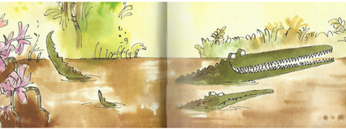
Year 3 Writing
Lesson 5
LO: To use adjectives and adverbs to innovate on an existing text
Task:
Think about what has happened so far in the story. The readers have been introduced to all the main animal characters and the Enormous Crocodile has a ‘clever plan’ to catch a child for dinner.
Make up an extra jungle creature character. Plan out who your character is and what it is like-draw a picture with words around it if that helps you get ideas. Think about the way the author has described animals that meet the crocodile- maybe you could attempt to copy Roald Dahl’s style. Write an extra section of the story to introduce your character and describe what happened to it when it met the crocodile. Be creative, and it’s up to you if your character is a nice one - or a bad one who joins in with the Enormous Crocodile.
Try to make your extra section of story look like pages from the book with layout and illustrations.
Make sure you include examples of adjectives and adverbs- you might be able to use some of the words you have generated through the week or some of the words the author used in the book.
Success Criteria:
- Describe your character and include interesting details to help the reader imagine.
- Make sure you include adjectives to describe nouns.
- Make sure you include adverbs to describe verbs.
- Group ideas together in paragraphs.
- Use correct basic punctuation and try to use a variety of sentence types, word order and sentence starters to avoid boring repetition.

Extra challenge (optional):
Try to include some metaphors or similes in your extra part of the story.

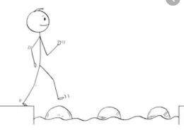
Year 3 Writing
Steppingstone activity
Lesson 5
LO: To use adjectives and nouns in story writing
Task:
Look at the new character in the jungle.
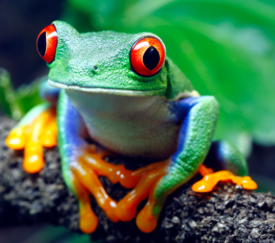
Think about how it looks and imagine what its personality is like.
Draw a picture of the frog.
Write at least 4 sentences to describe what the jungle frog is like and what it does.
Make sure you describe nouns with an adjective and verbs with an adverb in the way you practised this week. You can write about it meeting the crocodile if you want to.
Success Criteria:
- Write some sentences that tell the reader about the frog.
- Join the sentences together so it creates a short section of story.
- Try to include adjectives to describe nouns.
- Try to include adverbs to describe verbs.
- Include correct, basic sentence punctuation (capitals/full-stops).

Example:
There was a colourful frog in the green jungle with big, yellow feet that made him hop high in the air. The frog jumped around cheerfully.

