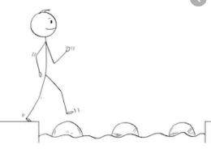
Year 2 Writing
Lesson 5 Steppingstone activity
What like?

adjective
brown
big
cheeky
soft
fluffy
Friday 27th March 2020
LO: To use adjectives to describe

The monkeys.

Success Criteria:
- Say the sentence (EG: The brown monkeys.)
- Write your sentence in your book.
- Draw a picture of the monkeys that you have described.

Challenge: Include verbs in your sentence.
Verbs
swinging, playing, talking, jumping, running
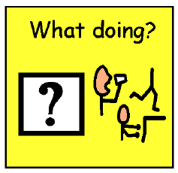

Year 2 Writing
Lesson 5
Friday 27th March 2020
LO: To use adjectives to describe
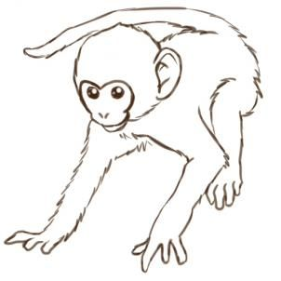

Success Criteria:
- Write sentences to describe the monkeys using adjectives.
- Draw pictures of the monkeys you have described.

Adjectives | Nouns | Verbs | Adverbs
brown, cheeky, fluffy, furry, cute, beige, black, smiley, playful, naughty | monkey, man, tree, hats, branch, ground | swinging, laughing, teasing, pointing, shouting, playing, grabbed, eating, smiling, took | energetically, quickly, loudly, cheekily, swiftly, smoothly, carelessly

Challenge: Include verbs and adverbs in your sentences to add more detail to your writing!

EG: The brown, cheeky monkeys were swinging energetically on the flaky branches. They quickly grabbed hats from the ground and teased the poor man by laughing loudly and pointing.

