Year 1 Writing
Lesson 5
Friday 27th March 2020
LO: To retell a story
Draw a story map like this for the story of Dogger. There should be a picture for all the main events with a few words to explain them.
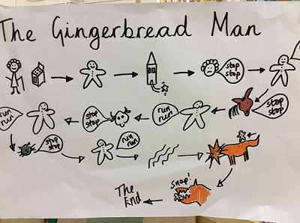

This is an example of a story map for The Gingerbread Man but your child should know how to do them as we have done lots.

Stepping Stone Activity:
Draw a picture for each of these sentences and copy the sentence to go with it.
Dave loves Dogger.
Dave loses Dogger.
They look everywhere for Dogger.
They find Dogger at the toy stall.
Bella gets Dogger back for Dave.
Dave is happy.

