Year 5 Writing
Lesson 5
LO: To write the next chapter of journey
Task (with links):
Watch this video clip: https://www.literacyshed.com/megacity.html
Jack and Harry have finally completed their dream of going to the countryside. Write a short narrative chapter of their life/ journey in the countryside.
Think about the following:
- Where do they live?
- What is Jack’s job?
- What will they do with their new life/ journey in the countryside?
Success Criteria:
- Include a description of the setting
- Include characters thoughts, feelings and hopes (using powerful vocabulary)
- Use show not tell sentences
- Include two fronted adverbials
- Include two subordinate clauses (extra information) with commas

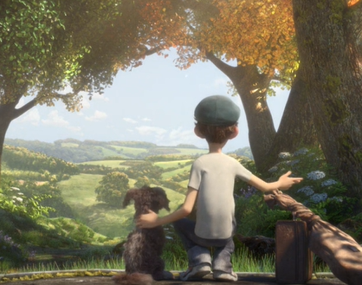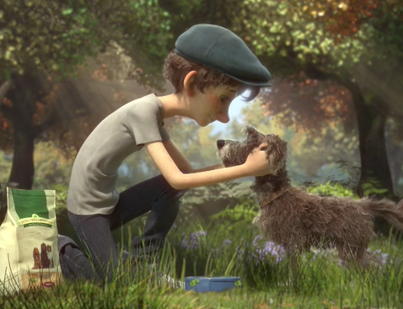
E.g. Jack and Harry, a miniature schnauzer, finally arrived at their long awaited destination, the countryside. It had taken them two years to leave the congested city, but now they were surrounded by greenery and the fresh smell of flowers.

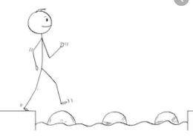
Year 5 Writing
Steppingstone activity
Lesson 5
LO: To write the next chapter of journey
Success Criteria:
Task (with links):
Watch this video clip: https://www.literacyshed.com/megacity.html
Jack and Harry have finally completed their dream of coming to the countryside. Write a short narrative chapter of their life/ journey in the countryside.

- Include a description of the setting – where had they arrived?
- Include characters thoughts, feelings and hopes (using powerful vocabulary)
- Use the following to help you organise your work
Where do they live?
What is Jack’s job?
What will they do with their new life/ journey in the countryside?
- Include two fronted adverbials
- Include a subordinate clause

Subordinate clause
E.g. Jack and Harry, a miniature schnauzer, finally arrived at the countryside. It had taken them two years to get there and now they were surrounded by greenery.
Use the vocabulary that you’ve created throughout the week to support you with your writing.

