Year 4 Writing
Lesson 5
LO: To use speech marks
Task (with links):
Watch this video clip: https://www.literacyshed.com/takingflight.html
In the film we do not see the alien, in your narrative Tony could meet one of them.
- Draw and then describe the alien (15 minutes)
- Create the dialogue that is had between the alien, Tony and Grandpa. (30 mins)
Use the images at the bottom of the page to see the character’s feelings. What might they say?
Success Criteria:
- Draw a picture of your alien
- Write a short description as a caption
- Use expanded noun phrases
- Create a dialogue between all three characters in space
- Remember to use speech marks
- Every new speaker starts on a new line
Model
As the ships closed in, Grandpa thought quickly. He slowly moved the rocket in front of the gigantic, menacing spaceship.
“Why are you chasing us?” asked Grandpa cautiously.
“You have found our planet! You must leave!”
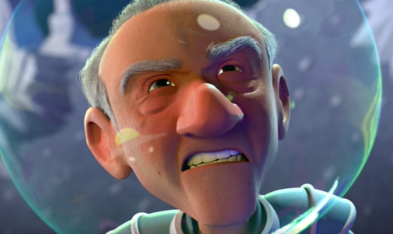
“We found the planet. Can’t we visit?” Tony asked bravely as the alien ship calmy floated.
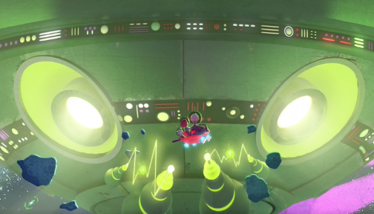
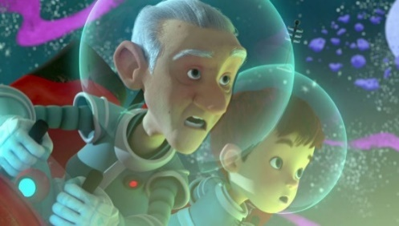
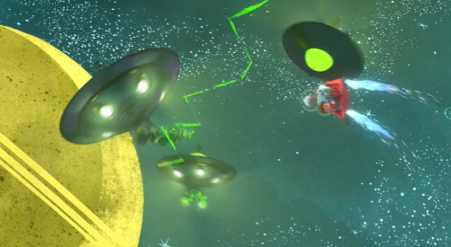
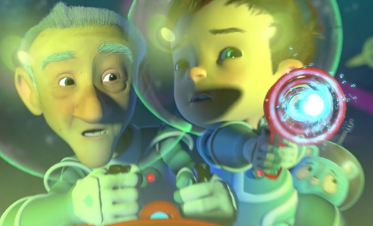
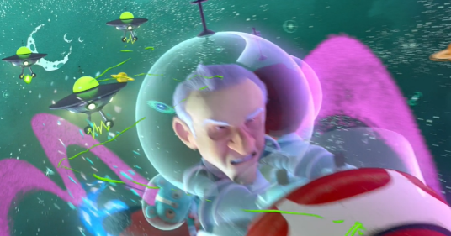

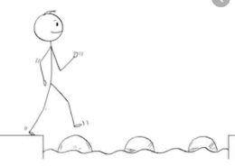
Year 4 Writing
Steppingstone activity
Lesson 5
LO: To use speech marks
Success Criteria:
Task (with links):
Watch this video clip: https://www.literacyshed.com/takingflight.html
In the film we do not see the alien, in your narrative Tony could meet one of them.
- Start by completing the speech bubbles at the bottom of this page
- Draw your alien (Or use the template on the next page)
- Write 1-3 things the alien might say in his speech bubble
Use the images at the bottom of the page to see the character’s feelings. What might they say?

- Complete the speech bubbles
- Draw or choose an alien
- Design your alien
- Write 3 sentences the alien would say to Tony and his Grandpa
- Remember to use speech marks
- EXT: What would Grandpa say back?
Model
“I will get those sneaky, nasty aliens!”
Model

