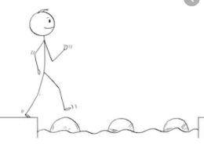
Year 4 Reading
Steppingstone activity
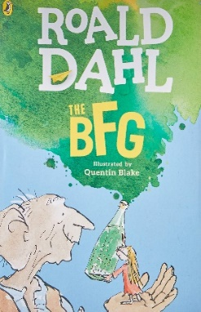
Date: Tuesday 31st March 2020
LO: To sequence events in order
Task:
Share the next chapter ‘The Marvellous Ears, with an adult or older sibling.
Order the events in the conversation between Sophie and the BFG from the first 2 pages of the chapter from 1 to 6.
- First event
6- Last event

Event: | Number (1-6):
Mrs Clonker would lock them in the cellar for a day and a night without food or water.
Sophie wants to know the BFG’s secrets
Sophie sat down once again on the enormous table.
The BFG starts crying because he feels sorry for Sophie.
The BFG will never let the giants eat Sophie for tea.
Sophie’s parents died when she was a baby,
EXT: Write another 2 events that come after these.
Year 4 Reading
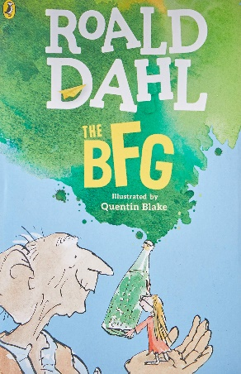
Date: Tuesday 31st March 2020
LO: To sequence events in order
Task:
Read the next chapter of the BFG - ‘The Marvellous Ears’.
Order the events from the chapter from 1 to 10.
- First event
10- Last event

Event: | Number (1-10):
Mrs Clonker would lock them in the cellar for a day and a night without food or water.
The BFG is a dream-blowing giant
The BFG’s ears mean he can hear almost anything
The BFG starts crying because he feels sorry for Sophie.
The BFG will never let the giants eat Sophie for tea.
Sophie’s parents died when she was a baby,
He catches dreams with a net and puts them in to bottles
Sophie sat down once again on the enormous table.
The BFG loses interest in the conversation and is hungry
Sophie wants to know the BFG’s secrets
EXT: Write another 2 events and write which numbers they would come between.

