Song: Teddy Bear Picnic

<https://www.bbc.co.uk/cbeebies/watch/my-pet-and-me-teddy-bear-picnic>

1. Literacy: Handwriting warm up: practice forming the letters: m n r b p

(remember to say the description for each letter as you write it).

1. Imagine if it was you and not Jack that climbed up the beanstalk, what do you think you might have seen in the castle, what might you have taken – or even given to the giant? Or perhaps it wasn’t a bean plant, maybe it was an apple seed, a sunflower seed or a different type of seed entirely. What would you use to chop the plant down?

Change just one thing in your story. This could be either:

* Jack (*yourself, your dad/granny/sister/aunty…)*
* What he sold for the magic seeds (*pet cat, rabbit, goldfish…)*
* The plant that grew (*a pea, sunflower, tomato, chilli…)*
* Who lived in the castle (*dragon, witch, evil villain…)*
* What was taken from the castle (magic cooking pot, toilet roll…)

Today have a think about what you will change; draw it and stick it in place on the story map you have been given.

Physical: Do some Teddy Bear Aerobics!

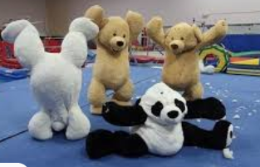

Song

<https://www.youtube.com/watch?v=LM2ixB2ybeI>

Listen to the story and sing along.

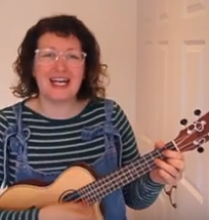

This week’s

Expressive Arts and Design

Make an Easter Card for someone in your family as a nice surprise!

Maths: Halving - if you can use real objects (eg pegs) it’s even better!

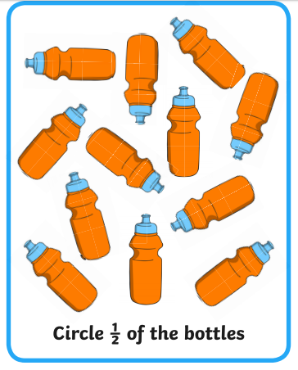 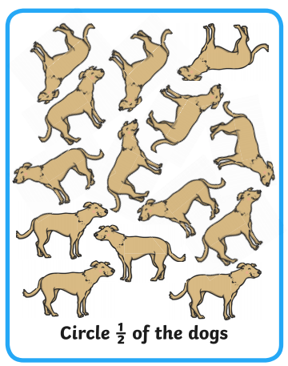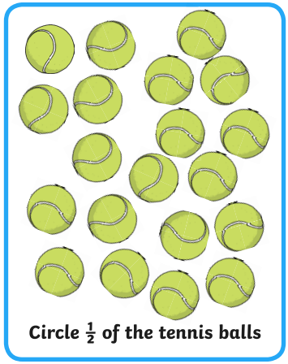

What is half of 20? Half of 18? Half of 16? Half of 14? Half of 12?

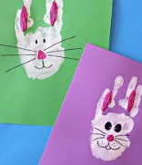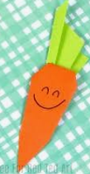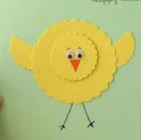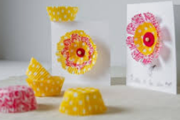

**Phonics: It’s time for those tricky old red words**

The red words children need to know by the end of Reception year are:

|  |  |  |
| --- | --- | --- |
| Phase 2 | Phase 3 | |
| I  no  go  to  into  the | he  she  we  me  be  you | are  her  was  all  they  my |

Red words are a set of words that we do not sound out as they do not follow the pattern of phonics the children are learning to use; so, practise sight reading these words at home.

Ideas that can help could include:

* Write the words on pieces of card (this could be an old cereal box cut up) and use them as flash cards.
* These cards could also be turned face down to make up a game of memory
* Why not make twice as many cards and play a game of snap
* Watch out for them in story books and count how many there are; I wonder whether there is a particular word that is used more than others?

If you feel your child is ready for more of a challenge, then begin to learn to spell the words. This can be using the Look, Cover, Check, method i.e.

<https://www.twinkl.co.uk/resource/t-l-4758-phase-3-tricky-words-on-writing-practice-worksheets>

