Year 1 Writing
Lesson 7
Tuesday 31st March 2020
LO: To describe a setting
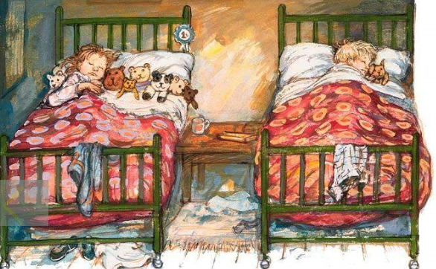

Look at the picture of Dave and Bella’s bedroom. Can you describe it in detail to a grown up? Remember to use lots of adjectives (describing words).

Stepping Stone Activity:
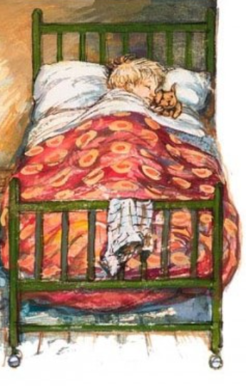
Describe Dave in his bed.

