Year 5 Writing
Lesson 3
LO: To consider character thoughts
Task (with links):
Watch this video clip: https://www.literacyshed.com/megacity.html
Look at the pictures you have been given.
Create a comic strip about the video with thought bubbles for the characters.
Include a narrative to explain what the characters are doing in each event.

I really don’t want to travel into the city, but I’ve got to go. This is the only way I can get out of here and go to the countryside.

I wish this day would be over soon. I’m hungry and tired. I’m pretty sure Harry is tired and would like a warm meal.

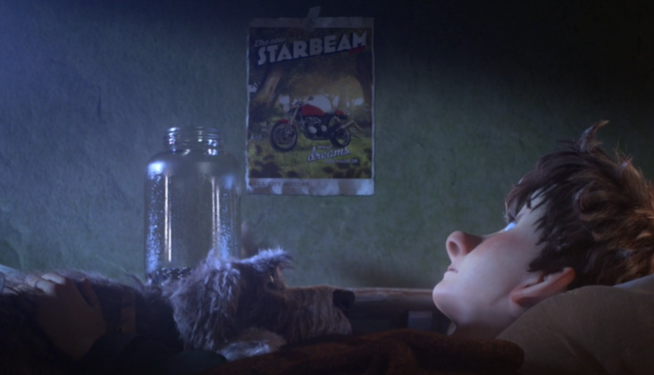
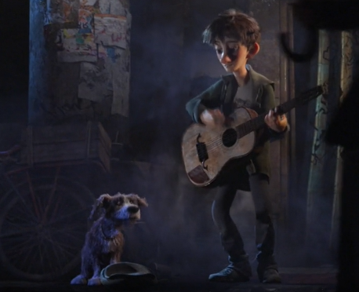

Soon after getting home from another tiresome day in the city.
Jack and Harry busking outside the chaotic city centre.

Narrative

