Task 1 | Task 2 | Task 3 | Task 4
Developing Task Answers  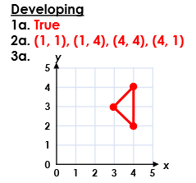  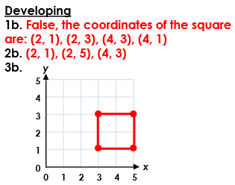  Practice  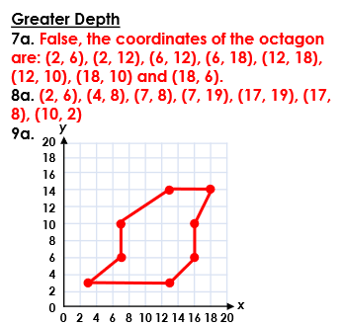 | Arithmetic  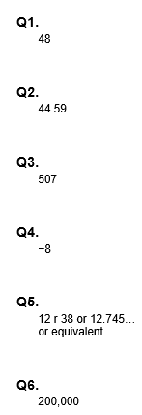 | Reasoning  Explain your answers.  Task 1  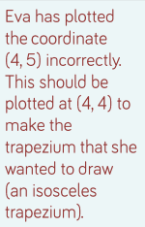  Task 2  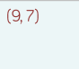 | Problem solving  Task 1  (a) Award ONE mark for B is (55, 30)  1  (b) Award ONE mark for D is (55, 14)  If B and D are incorrect, ONE mark may be given for the correct y coordinate for both B and D and the same x coordinate (incorrect) for both points, i.e.  • D is (same x as B, 14)  Task 2  (–10, –40)

