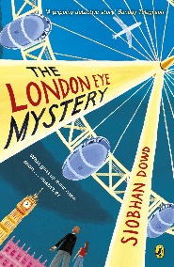
Year 5 Reading
Week 2, Lesson 4
LO: To make comparisons across a paragraph.
Activity: Re-read the 2 versions of the letter from Aunty Gloria. Write a paragraph comparing the 2 letters.
Success Criteria:
- Re-read Ted and Kat’s version of Aunty Gloria’s letter.
- Identify 2 similarities between the letters.
- Identify 2 differences between the letters.
- Use the sentence starters and useful words to write a paragraph comparing the letters (page 14-16).

Sentence starters | Vocabulary
There are a few similarities and differences between…  Similarities include…  Differences between the 2 letters are that…  There are multiple similarities between the letters, including...  Whilst there are some similarities there are also…  Unlike Kat’s letter, Ted’s letter is… | Similarly  Equally  Likewise  In contrast  On the other hand  Differ  Unlike

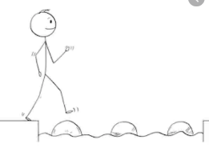
Year 5 Reading
Steppingstone activity
Week 2 Lesson 4
LO: To make comparisons across a paragraph.
Activity: Re-read the 2 versions of the letter from Aunty Gloria. Write 4 senetnces comparing the 2 letters.
Success Criteria:
- Re-read Ted and Kat’s version of Aunty Gloria’s letter.
- Identify 2 similarities between the letters.
- Identify 2 differences between the letters.
- Write 2 sentences about the similarities between the 2 letters.
- Write 2 sentences about the differences between the 2 letters.

Sentence starters | Vocabulary
There are a few similarities and differences between…  Similarities include…  Differences between the 2 letters are that…  There are multiple similarities between the letters, including...  Whilst there are some similarities there are also…  Unlike Kat’s letter, Ted’s letter is… | Similarly  Equally  Likewise  In contrast  On the other hand  Differ  Unlike

