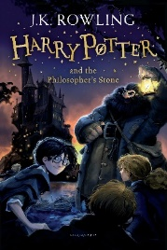
Year 6 Reading
Week 2, Lesson 4
LO: To infer using evidence from the text.

Success Criteria:
- Read the statement.
- Go to the given page number.
- Find evidence to support each statement.
- Write the evidence from the text in quotation marks.

Statement | Evidence from the text
The Dursley’s house had hardly changed after ten years. | ‘Only photographs on the mantelpiece really showed how much time had passed’.
The Dursleys did not make it obvious that Harry lived with them. (Page 19)
Mrs Dursley is very strict with Harry.(Page 20)
Harry and Mrs Dursley had a different opinion to each other about what Dudley looked like? (Page 22)
Dudley knew how to manipulate his mother. (Page 24)
The Dursleys treated Harry as though he was unimportant. (Page 24)
Mrs Dursley was not fond of Harry’s scar. (Page 25)

