Year 5 Writing
Week 2, Lesson 4
LO: To write in the role of a character
Task (with links):
Watch this video clip: https://www.literacyshed.com/megacity.html
Look at the pictures you have been given. Write a diary entry in the role of Jack to explain his thoughts and feelings and how his life changed from living in the city to living in the countryside.
Success Criteria:
- Write in the first person - Jack
- Write in the past tense
- Include characters thoughts, feelings and hopes (using powerful vocabulary)
- Describe the settings – city life and then the countryside
- Include fronted adverbials
- Include subordinate clauses (extra information) with commas

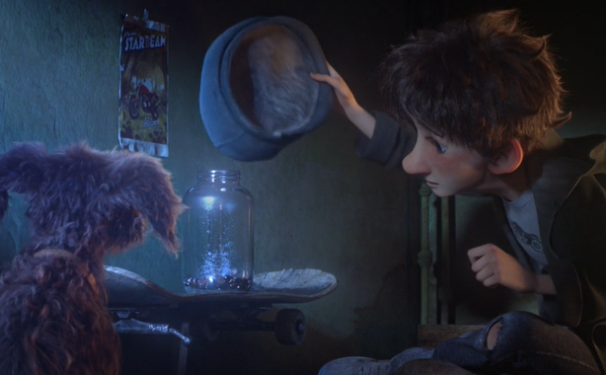
E.g. It was another miserable day and I longed to stay indoors but the hope of moving to the country pushed me outside. Harry was huddled in the back of the bike, always eager to go outside. I’m sure he will become as depressed as me once he sees where we go.

Year 5 Writing
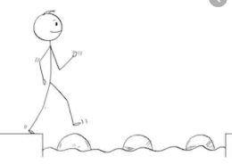
Steppingstone activity
Lesson 4
LO: To write in the role of a character
Success Criteria:
Task (with links):
Watch this video clip: https://www.literacyshed.com/megacity.html
Look at the pictures you have been given. Write a diary entry in the role of Jack to explain his thoughts and feelings and how his life changed from living in the city to living in the countryside.
- Write in the first person - Jack
- Write in the past tense
- Include characters thoughts, feelings and hopes (using powerful vocabulary)
- Describe the settings – city life and then the countryside
- Include fronted adverbials

Use these question prompts to help you?
What were you doing in the city?
Why were you playing a guitar?
What were you planning to do in the countryside?
What did you feel when you got there?
E.g. Dear Diary,
I was tired after another long day in the city. The weather was miserable and bitterly cold. Yet again people rushed by whilst I played a song in the background. Harry was sitting beside me receiving a few glances from people passing by.

