**Year 5 Writing**

**Lesson 1  
LO: To write descriptive sentences to create suspense**

Visit this web link and watch the video clip: <https://www.literacyshed.com/alma.html>

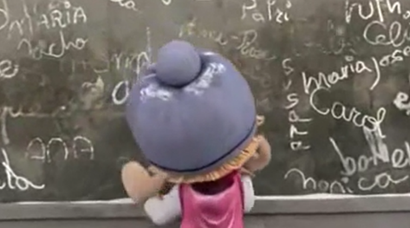Alma is a little girl who ventures into town in the snow.  
She is drawn to a shop window by a familiar looking doll.  
She enters the shop... what will happen when she goes inside?

What is the mood of the story?

What do you think will happen in the story?

**Task 1:**

In your book, generate some verbs and adverbs linked to what happens in the story. Follow the table below to help you organise your work.

|  |  |
| --- | --- |
| **Verbs (doing and being words)** | **Adverbs (describes the verbs)** |
| peeped | curiously |
| walked |  |

**Task 2:**

Use some of the above verbs and adverbs to create sentences which create suspense.

**E.g.**

**Curiously, Alma peeped into the shop window only to be caught by surprise when seeing a doll looking like her.**

**Success Criteria:**

|  |
| --- |
| 1. **Look at the picture** |
| 1. **Begin your sentence with a fronted adverbial** |
| 1. **Choose 2 adjectives or create your own** |
| 1. **Use a verb and adverb from your bank of ideas** |
| 1. **Create your sentence. Make sure you read it back to check it makes sense!** |

**Year 5 Writing**

**Steppingstone activity**

**Lesson 1  
LO: To write descriptive sentences   
Success Criteria:**

**Task (with links):**

Visit this web link and watch the video clip: <https://www.literacyshed.com/alma.html>

Alma is a little girl who ventures into town in the snow.  
She is drawn to a shop window by a familiar looking doll.  
She enters the shop... what will happen when she goes inside?



|  |
| --- |
| 1. **Look at the picture** |
| 1. **Choose a noun** |
| 1. **Choose 2 adjectives to describe the noun (or come up with your own!)** |
| 1. **Remember to use your punctuation** |

**Word bank:**

|  |  |
| --- | --- |
| **Adjectives** | **Nouns** |
| **Cheeky**  **Curious**  **Amazed**  **Beautiful**  **Small**  **shiny adventurous**  **glowing**  **thick**  **heavy**  **fluffy** | **snow**  **girl**  **window**  **door**  **E.g. An adventurous girl of eight, bounced along the road until a dazzling window captured her attention**  **doll**  **handle**  **shop**  **toys** |

