Task 1 | Task 2 | Task 3
Developing Task Answers  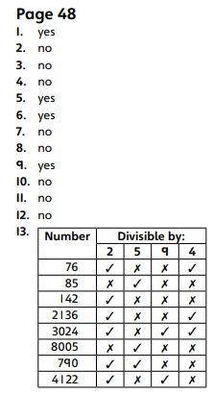  Practice  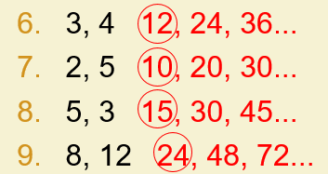  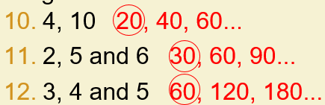 | Reasoning  Explain your answers.  Task 1  Rings around 45, 20 and 40  All three numbers must be indicated for the award of the mark.  Accept any other clear way of indicating the correct numbers.  Task 2  Number sequence completed as shown:  All three numbers must be correct and in the order shown for the award of the mark.  Task 3  Correct number given as shown:  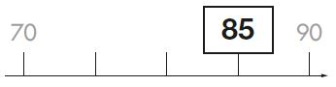 | Problem solving  Task 1  Three correct fruits ticked as shown:  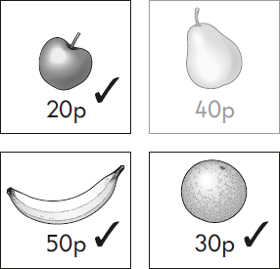  Accept any other clear way of indicating the correct fruits shown on the page e.g. 50p + 20p + 30p = 100p or £1  Task 2  Number sequence completed as shown:  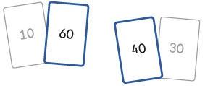  Both numbers must be correct for the award of the mark.

