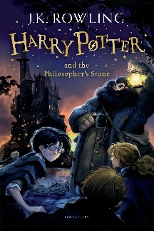
Year 6 Reading
Week 2, Lesson 1
LO: To read for pleasure.
Success Criteria:
- Read chapter 2 of your guided reading book: Harry Potter and the Philosopher’s Stone.
- Write bullet-pointed notes in your exercise book about the key characters and main events that take place in this chapter.

Example notes
- Harry Potter had been living with the Dursleys for the past 10 years.
- The photographs showed how much time had passed.
- Inside the living room, there was no sign that Harry existed.

