Song: Sing a Rainbow

<https://www.bbc.co.uk/teach/school-radio/nursery-rhymes-i-can-sing-a-rainbow/zn3tqp3>

Literacy:

1. Handwriting warm up: practice forming the letters: m n r b p

(remember to say the description for each letter as you write it).

1. Continue your bean diary:

* It’s been one week since you planted your bean seed. Has anything exciting happened?
* Draw a picture of what your bean looks like and label the parts you can see. Then write a sentence about your bean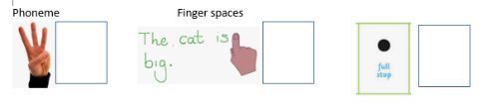
* Remember to keep up the care of your plant. Keep in near sunlight and don’t let the soil dry out…I wonder how tall your plant will grow; will it be as tall as a wellington boot, a table, a wardrobe or will it grow tall enough to reach your ceiling or even the clouds?
* Why not send me a message on Tapestry with how tall you think your beanstalk will grow.

Physical Use materials around the house to make a rainbow pattern.

This week’s

Expressive Arts and Design

Make an Easter Card for someone in your family as a nice surprise!

Song: Did you ever see a bunny?

<https://www.bbc.co.uk/teach/school-radio/nursery-rhymes-did-you-ever-see-a-bunny/z7vmd6f>

Maths: Halving - use your toys or people to share a group of objects between 2 to find half. Remember, you can use lego bricks, pieces of pasta, beads, balls of playdough etc.

If you don’t have the toys or the objects to share, draw a picture of them.

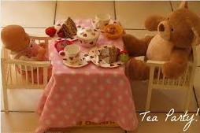 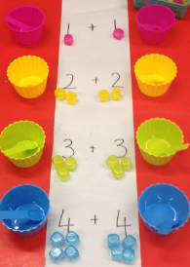

What is half of 10? Half of 8? Half of 6? Half of 4? Half of 2?

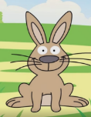

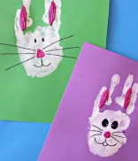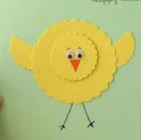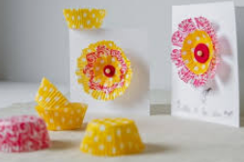

**Phonics: It’s time to tackle those tricky old red words this week. Many of these will already be familiar to your child as we have been working on them in school; however, practise makes perfect. So, select a few each day and keep working on them across the whole week, let your child’s interest dictate the pace and remember, take frequent breaks and give each other lots of praise.**

The red words children need to know by the end of Reception year are:

|  |  |  |
| --- | --- | --- |
| Phase 2 | Phase 3 | |
| I  no  go  to  into  the | he  she  we  me  be  you | are  her  was  all  they  my |

Red words are a set of words that we do not sound out as they do not follow the pattern of phonics the children are learning to use; so, practise sight reading these words at home.

Ideas that can help could include:

* Write the words on pieces of card (this could be an old cereal box cut up) and use them as flash cards.
* These cards could also be turned face down to make up a game of memory
* Why not make twice as many cards and play a game of snap
* Watch out for them in story books and count how many there are; I wonder whether there is a particular word that is used more than others?

If you feel your child is ready for more of a challenge, then begin to learn to spell the words. This can be using the Look, Cover, Check, method i.e.

<https://www.twinkl.co.uk/resource/t-l-4758-phase-3-tricky-words-on-writing-practice-worksheets>

