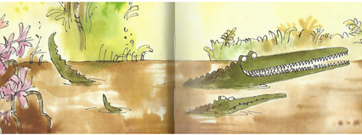
Year 3 Writing
Lesson 1
LO: To use a variety of speech verbs
Task:
Read up to end of P 13 (The Enormous Crocodile swam to the side of the river, and crawled out of the water).
Look at the words that the characters say (direct speech).
Read the direct speech carefully to remind yourself of the punctuation rules.
Think about what a speech verb is (a word that means said).
The author has used the same speech verb many times. Can you see where he has chosen a speech verb other than said? Make a list of all the speech verbs you can see he used.
Rewrite a minimum of 5 things that the characters said with a different speech verb of your own choice. Try to choose speech verbs that give a clue to the way the words were spoken. Make sure you check that the sentences are correctly punctuated and the words from the book are spelt accurately.

Success Criteria:
- Start direct speech with a capital letter.
- Choose a different speech verb (that means said) for each sentence.
- Enclose direct speech with inverted commas (“speech marks“).
- Separate direct speech with a comma.
- Start each new sentence on a new line.
- Put punctuation inside the closing speech mark.
Word bank: (you do not have to choose these speech verbs- they are just a suggestion)
whispered | shouted | yelled | asked | replied
screeched | laughed | mumbled | cried | announced

E.g. “I’m the cleverest croc on the whole river,” the Enormous Crocodile screamed.

Extra challenge (optional):
Write a dialogue of your own between the two crocodiles- or even additional jungle creatures from your imagination. Remember that each time a different character speaks, you must start a new line.

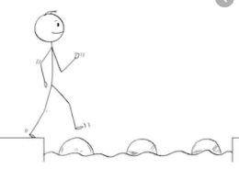
Year 3 Writing
Steppingstone activity
Lesson 1
LO: To use a variety of speech verbs
Task:
Share the book with an adult or older sibling up to end of P 13 (The Enormous Crocodile swam to the side of the river, and crawled out of the water).
Look at the words that the characters say (direct speech) – can you see the speech marks?
Think about what direct speech is (the words a character says).
Draw the two crocodiles and put in speech bubbles to record what they say.

Success Criteria:
- Say the words you think the characters said.
- Draw the characters and make a speech bubble to record the words the characters said.

Word bank: (you do not have to choose these speech verbs- they are just a suggestion)
said | shouted | asked | replied

Extra challenge (optional):
Write some sentences to record what the characters you drew said. Try to use speech marks and include a speech verb.
E.g. The Enormous Crocodile shouted, “I want to eat a nice juicy child!”
