Year 5 Writing
Lesson 2
LO: To plan a narrative that includes suspense
Main Idea for the Paragraph | Show not tell sentences to describe feelings | Verbs and Adverbials to describe action
1 | Feelings:
2 | Feelings:
3 | Feelings:
4 | Feelings:
5 | Feelings:
6 | Feelings:

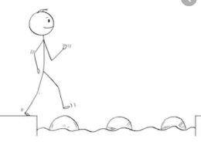
Year 5 Writing
Steppingstone activity
Lesson 2
Main Idea for the Paragraph | Description of characters feelings | Verbs and Adverbials to describe action
Eg. | Curious Mischievous  Excited | Excitement bubbled in her stomach  With curiosity, she looked into the store.
1 | Feelings:
2 | Feelings:
3 | Feelings:
4 | Feelings:
5 | Feelings:
6 | Feelings:

