Physical:

Make some number cards 1 – 9 and Let’s Get Moving cards.- on Tapestry. Shuffle both lots of cards and place face down in two different piles. Children choose an exercise card and a number card. Repeat the exercise on the card the same number of times as the number card. To make the activity more challenging, you might increase the numbers on the cards up to 20, or choose two and add them together.

Literacy:

Pretend you are going on a bus journey- where will you travel to? Will it be a real or imaginary place? You could pretend to be on the bus using a plate or Frisbee as the driving wheel and set off into your adventures. You might want to look at an atlas, a travel brochure, books or online for inspiration. If you are travelling far, you might want to pack a suitcase or a backpack. You could discuss what you might need for a beach holiday or a visit to Santa in an icy landscape. Can you design a bus? You can draw it and perhaps create one. Use your imagination

and think about what special features your

bus will have. Be inventive. It could even be

a flying bus. Encourage children to think

about being a designer, a scientist and an

artist whilst they are imagining their

creations.

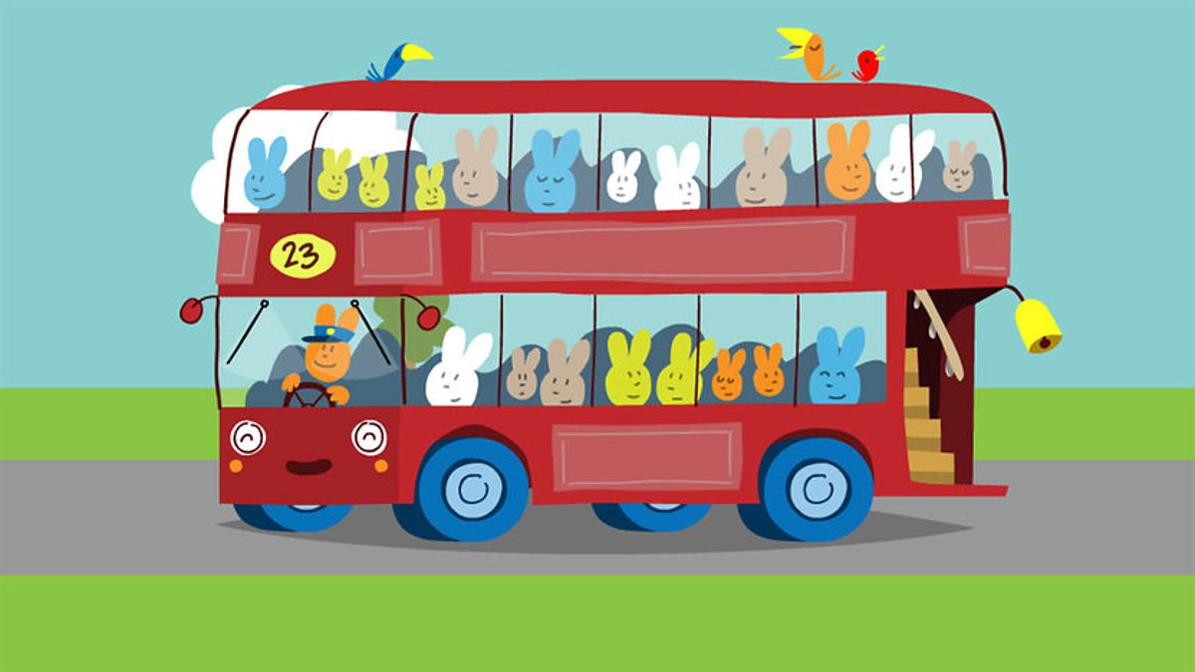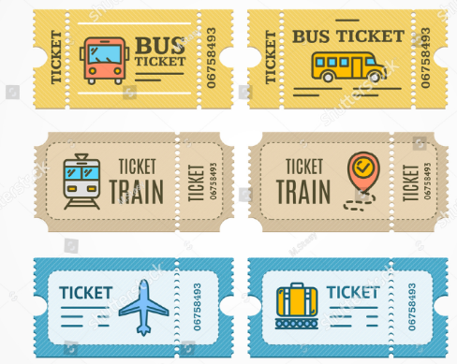

Phonics:

Draw a bus and some people who are going to get on- can we think of some names for the people on the bus? Can you make them silly, rhyming names? You could make it more interesting and they could be aliens or animals! “Ellie Lellie is getting on the bus!” “Patty Catty is sitting at the front!”

Maths:

Why not make your own tickets for the bus. What price will they have on them? Will they be 5p, 10p, 20p, etc? If not, think back to last week when you had your own café/ shop- why don’t you use the same currency you made up then, or create a new currency!

One person could be the bus driver and the

other could be the passenger and use the

money to pay for the ticket. This will help

your children learn about the coin’s value

and gain an understanding of money.

Song:

The Wheels On The Bus- how many different things might you hear on the bus?

This week’s Expressive Arts and Design:

Design your own Easter Egg using whatever materials you have in the house. Initially, use pens, pencils or even paint. You could then find some tissue paper, feathers, sequins, glitter if you have it! Demonstrate scrunching tissue paper for different effects and holding their scissors correctly. I found this little rhyme to support this-

Open shut, open shut, that’s the way we cut, cut, cut. Fingers on bottom, thumb on top, do not let the paper drop!