Literacy: Story telling

1. Literacy: Handwriting warm up: practice forming the letters: m n r b p

(remember to say the description for each letter as you write it).

1. Using your idea from yesterday, draw your own story map of your new beanstalk story and use it to tell your story to the other people in your house. Remember to use the actions we have been practising in school e.g.

Once upon a time (open hands like a book)

Who (index finger makes circle in the air)

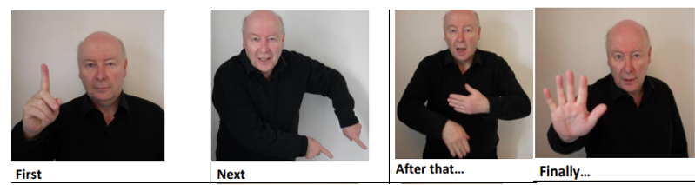

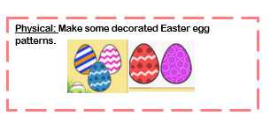

This week’s

Expressive Arts and Design

Make an Easter Card for someone in your family as a nice surprise!

Song: Chick Chick Chicken

<https://www.youtube.com/watch?v=BUBq5RsIYDg>

Maths: Half and double **Spot the difference**



**Draw a row of six big coloured spots.**

**◻ In turn, one player closes his or her eyes.**

**◻ The other player hides half of the spots with a sheet of paper.**

**◻ The first player looks and says how many spots are hidden.**

**◻ How did you know? What have you found out? (That 3 is half of six, that double 3 is 6)**

Repeat with rows of objects from 2 to 20.

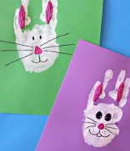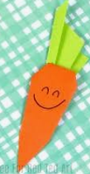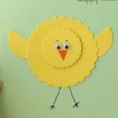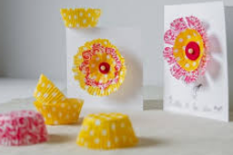

**Phonics: It’s time for those tricky old red words**

The red words children need to know by the end of Reception year are:

|  |  |  |
| --- | --- | --- |
| Phase 2 | Phase 3 | |
| I  no  go  to  into  the | he  she  we  me  be  you | are  her  was  all  they  my |

Red words are a set of words that we do not sound out as they do not follow the pattern of phonics the children are learning to use; so, practise sight reading these words at home.

Ideas that can help could include:

* Write the words on pieces of card (this could be an old cereal box cut up) and use them as flash cards.
* These cards could also be turned face down to make up a game of memory
* Why not make twice as many cards and play a game of snap
* Watch out for them in story books and count how many there are; I wonder whether there is a particular word that is used more than others?

If you feel your child is ready for more of a challenge, then begin to learn to spell the words. This can be using the Look, Cover, Check, method i.e.

<https://www.twinkl.co.uk/resource/t-l-4758-phase-3-tricky-words-on-writing-practice-worksheets>

