Literacy:

You might want to make your own farm. It could be on the floor, a table top or in a tray. Use different materials and boxes to create different parts of the farm. You could draw the landscape on a piece of paper and then use different cloths (e.g yellow duster) for different coloured fields. You could use a shoe box as a farm house and create some fences to keep the animals together and safe. Why don’t you make a little pond as well!

Find some toy farm animals or draw some of your own-

you could make them with different materials; cotton wool

for sheep or using feathers for the ducks. Have a look at

different websites and books about farm animals- what

differences can you see between cows? What is a baby

duck called? Have lots of discussions and think about the

language you are modelling. When you have created your

farm act out stories together, PLAY. 😊

What might happen if someone leaves the gate open? Perhaps you can

go looking for the hen’s eggs in the straw (chopped up old newspaper).

Physical:

Make some animal movements with your body! Check out: <https://www.hellowonderful.co/post/animal-exercises-for-kids/>

for some ideas. Can you walk around whilst making the movement?

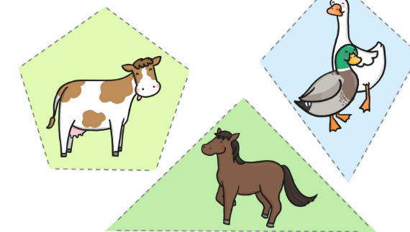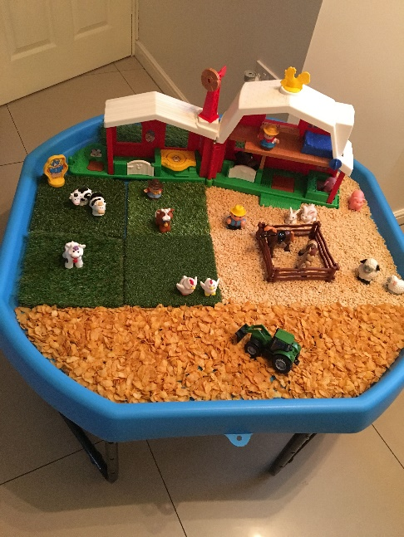

Phonics: I Spy- can you use the sheet on Tapestry to play a game of I Spy? Play this game by just describing what you can see, this can develop their vocabulary and understanding. For example, I spy with my little eye, something that is round and yellow with a smiley face. See if your child can then do the same, after you have modelled a few of them to guess! You can also do this around the house!

Song:

Old MacDonald Had A Farm- how many different animals can you think of? What if you changed the words to jungle- what animals would you find there?

This week’s Expressive Arts and Design:

Design your own Easter Egg using whatever materials you have in the house. Initially, use pens, pencils or even paint. You could then find some tissue paper, feathers, sequins, glitter if you have it! Demonstrate scrunching tissue paper for different effects and holding their scissors correctly. I found this little rhyme to support this-

Open shut, open shut, that’s the way we cut, cut, cut. Fingers on bottom, thumb on top, do not let the paper drop!

Maths:

Using the farm animals, why don’t you create groups of each animal- which group has more? Which has less? How can you tell? Can they estimate which has more/ less and then count to check?

You could also look at shapes today- there is a farm themed shape cutting activity you could use if you have

a printer, or why don’t you find different

objects that make a range of shapes in

your house. You could draw around them

and cut them out. Talk about what is the

same or different about them.