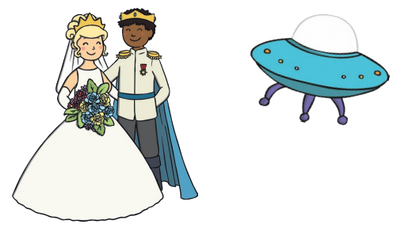

Physical:

How many times can you bounce a ball or hop on one foot?

Can you try some threading today? If you have string and beads you could count how many beads you can fit on it? If not, you could thread string/ pipe cleaners through a colander, or cheerios through spaghetti (if you want to use your pasta…)

Literacy:

Why don’t you choose your child’s favourite story, or maybe even one you’ve never read before and think of a new ending/ guess the ending! You could draw a picture of the characters in the book, describe them and talk about what might happen in the new ending. Would you introduce a new character or just change the idea behind the ending?

You could act out the new scene afterwards,

encourage language and expression- do the

characters have different voices?

Song:

Hickory Dickory Dock- can you think of different rhymes to count past 3? The clock struck 4, the mouse said, more!

Phonics:

Using the I Spy mat or playing around the house, move onto sounds. When you are saying “I Spy something beginning with a”, make sure it is the sound that they can hear at the beginning of the word, not the letter name. There are lots of YouTube videos that list the sounds for you if you need help but maybe say the word and listen to the sound first. You can hear the ‘a’ sound in apple instead of the letter name ‘A’.

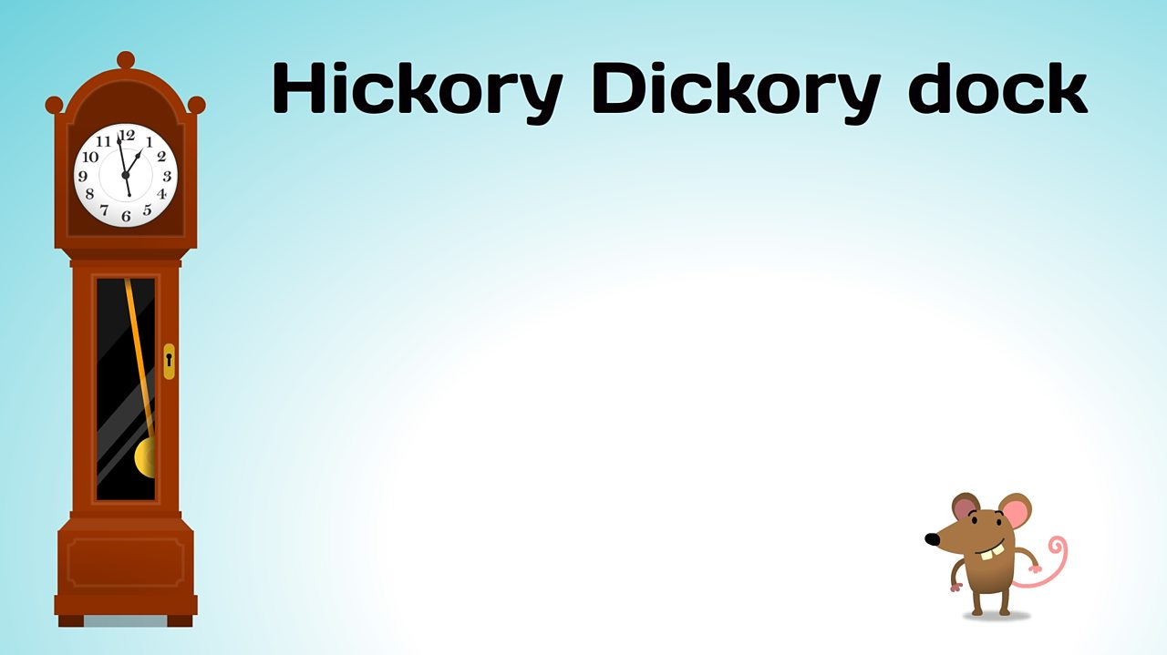

Maths:

When we sing Hickory Dickory Dock, we clap the same number of times that the clock strikes.

Hickory Dickory Dock, the mouse ran up the clock, the clock

struck one (clap and say one), the mouse ran down, Hickory

Dickory Dock, tick tock.

Hickory Dickory Dock, the mouse ran up the clock, the clock

struck two (clap and say one, clap and say two), the mouse

said boo! Hickory Dickory Dock, tick tock.

Hickory Dickory Dock, the mouse ran up the clock, the clock

struck three (clap and say one, clap and say two, clap and say

three), the mouse said weeeee, Hickory Dickory Dock, tick tock,

tick tock, tick tock.

Can you count other actions? You could count how many jumps

you can do, count the amount of spoons you put in a bowl when

cooking or how many times your toy car can drive around your

bedroom. You could also make your own clock- practise

recognising numbers.

This week’s Expressive Arts and Design:

Design your own Easter Egg using whatever materials you have in the house. Initially, use pens, pencils or even paint. You could then find some tissue paper, feathers, sequins, glitter if you have it! Demonstrate scrunching tissue paper for different effects and holding their scissors correctly. I found this little rhyme to support this-

Open shut, open shut, that’s the way we cut, cut, cut. Fingers on bottom, thumb on top, do not let the paper drop!

