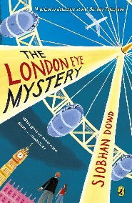
Year 5 Reading
Lesson 1
LO: To read for pleasure.
Success Criteria:
- Read chapter 1 of your guided reading book: A giant Bicycle wheel.
- Write bullet pointed notes in your exercise book about the key characters and main events that take place.

Example
- Ted’s favourite thing to do is fly the London Eye.

