Week beginning 29th June 2020
Year 1 Topic Flight
LO: To know what urban birds eat
What do city birds eat?

Watch the video clip to see what birds in cities eat.

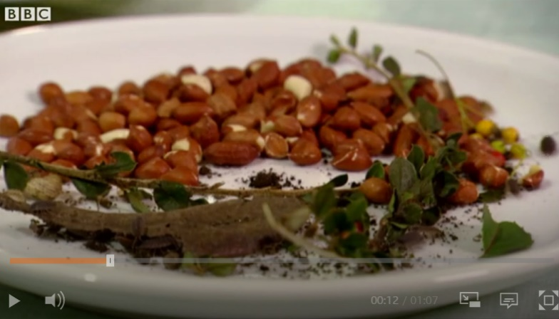
https://www.bbc.co.uk/bitesize/clips/zbx2tfr#:~:text=Nuts%2C%20insects%2C%20worms%2C%20slugs,all%20contribute%20to%20their%20diet.&text=The%20clip%20could%20provide%20a,to%20recognise%20and%20identify%20them.

Sometimes in winter birds cannot find enough to eat, especially if the weather is cold.
People help them by putting out food for them.

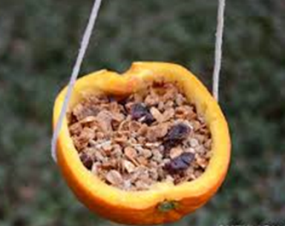

Today we are going to make our own bird feeder.
Watch my video on class dojo and follow the instructions.
Alternatively, you could make a different type of bird feeder.

