Year 4 Maths
Steppingstone activity
Lesson 1
LO: To multiply 2 digit numbers by 1 digit
Success Criteria:
- Draw your part/whole model
- Multiply the tens x ones
- Multiply the ones x ones
- Add them together

Model
- 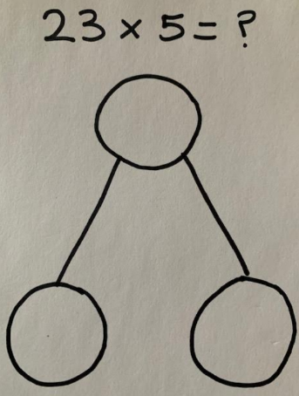 2. 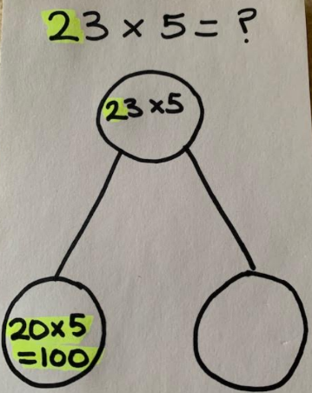 3. 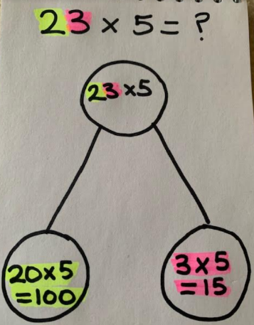 4.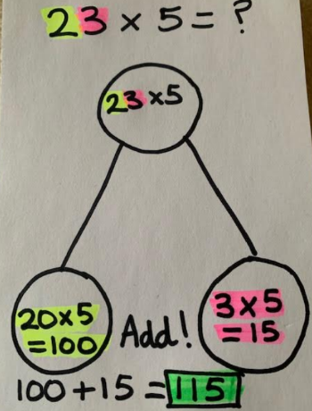

Now you try…
32 x 2 = ? 21 x 3 = ? 45 x 2 = ? 62 x 3 =? 52 x 4 = ? 63 x 5 = ?
Then, come up with some of your own!
Year 4 Maths
Lesson 2
LO: To multiply 3-digit numbers by 1-digit
Task:
You are going to practise multiplying! You can choose to do the expanded method or the short method.
Success Criteria:
- Layout your multiplication accurately (brackets in line with answers)
- Multiply the ones
- Multiply the tens
- Multiply the hundreds
- Add your answers together

Model:
- 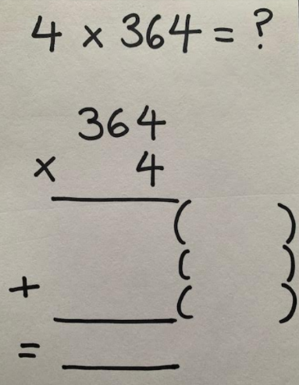 2. 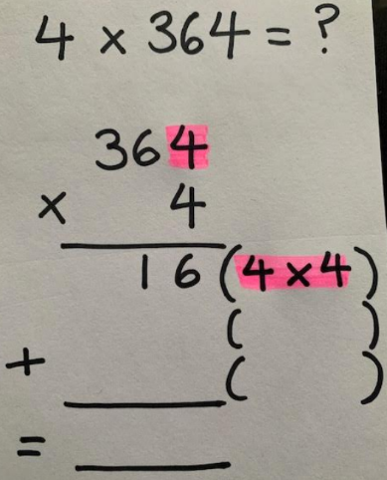 3. 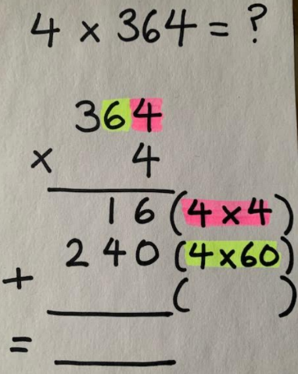 4. 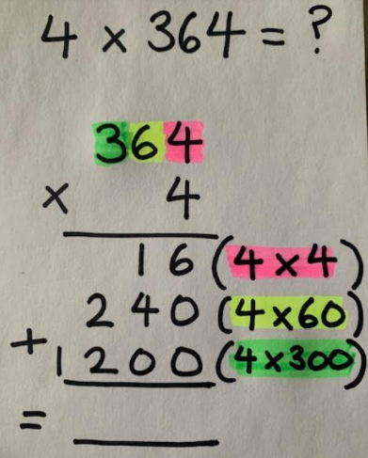 5. 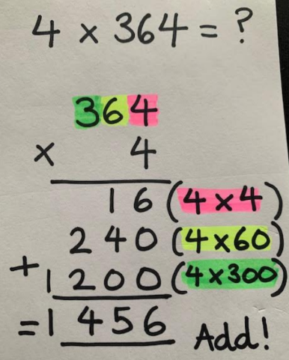
Make sure all your answers are in the correct columns!!!
Year 4 Maths
Main activity
Complete at least 2 columns, more if you can!
Task 1 | Task 2 | Task 3 | Task 4
Practice  Have a go at these multiplications. Use the expanded method:  121 x 3  231 x 2  415 x 3  241 x 5  623 x 2  324 x 5 | Practice  Have a go at these multiplications. Use the expanded or short method:  136 x 4  263 x 5  627 x 3  721 x 6  824 x 7  982 x 9 | Reasoning  Explain your answers.  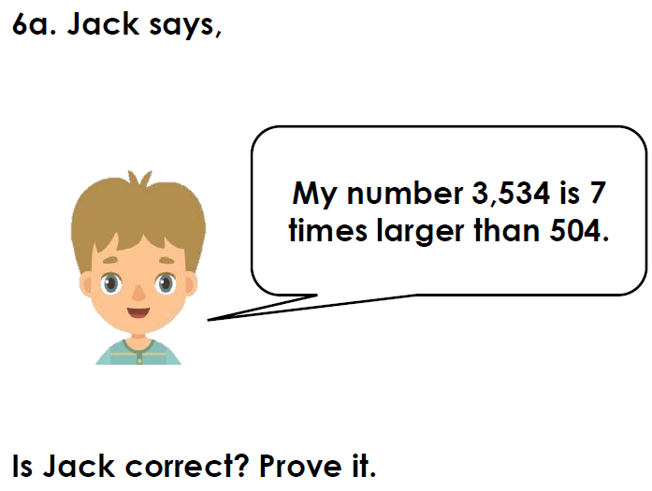  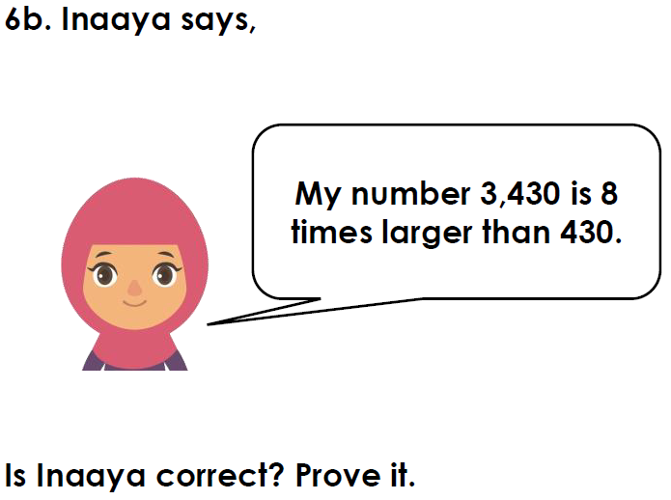 | Problem solving  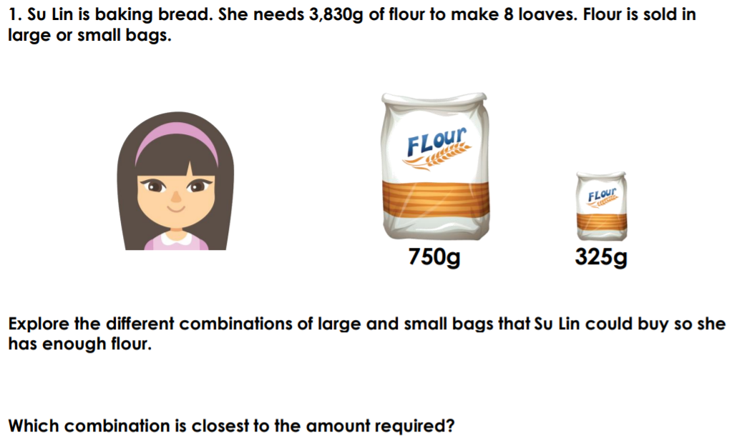  Hint: You will need to use trial and error. E.g. Start off with:  4 x 750  3 x 325  Then keep trying other combinations  Don’t forget to keep adding your 2 answers to get the total!  How many combinations can you come up with?

