Well, would you believe it?! Jeff Bob and Jumanji have been up to their tricks again whilst we’ve been away… they were found rifling through Sarah’s dressing up clothes and making a right old mess! I wonder where they were going in those fancy hats…
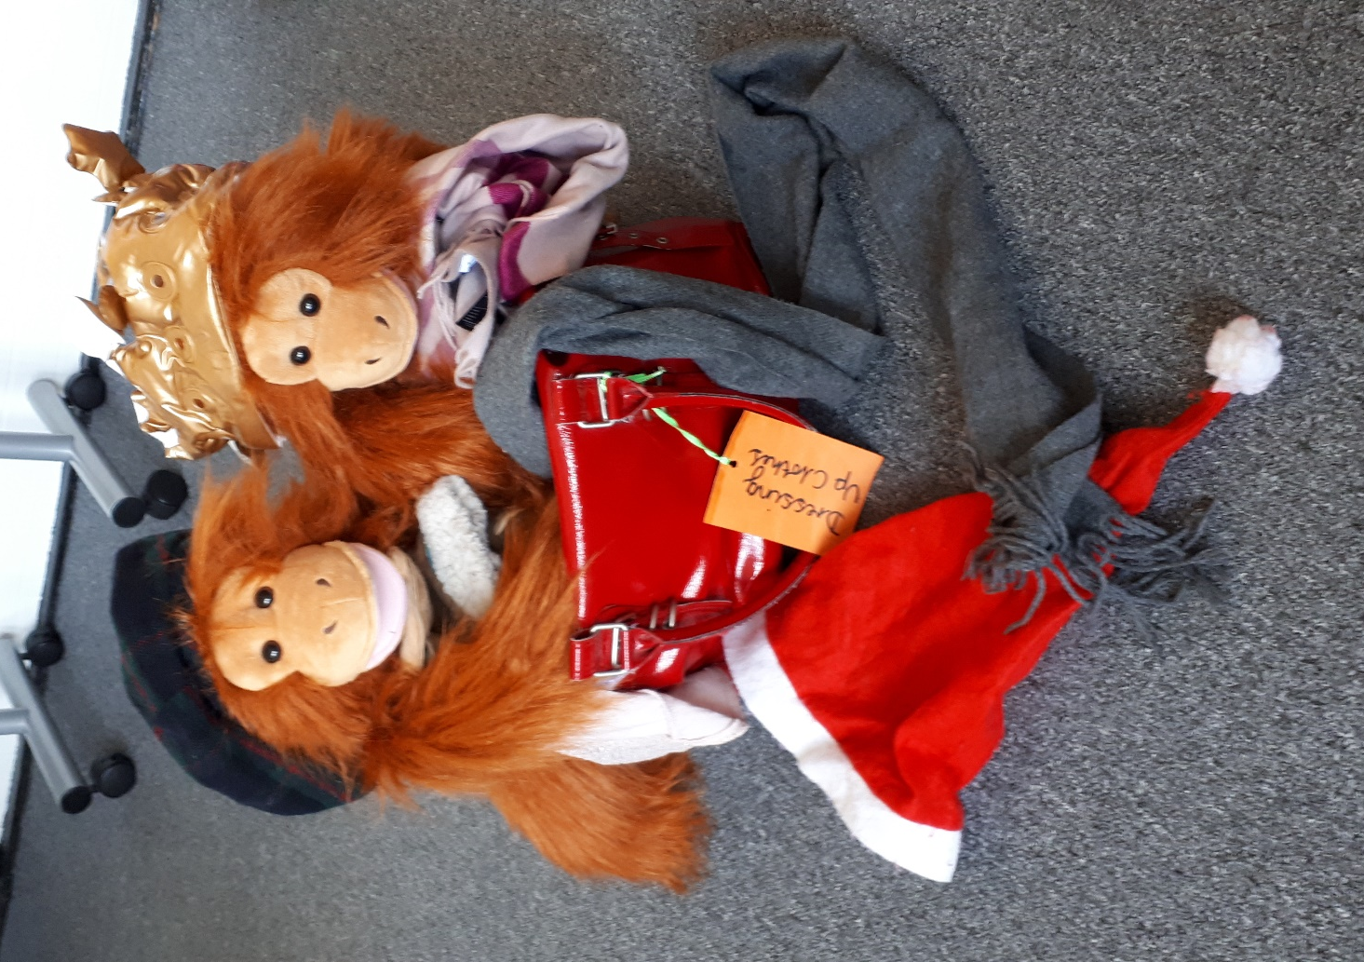
If you like, you could write a Jeff Bob and Jumanji adventure story and describe all the naughty antics the apes get up to! We would love to hear them.

Xx Sarah and Juliet

